

UsabCheck

Interim Report

DT228

BSc in Computer Science

**Damian Wojtowicz**

**C17413722**

**Andrea Curley**

School of Computer Science

Technological University, Dublin

**14/12/2020**

Abstract

The return on investment for usability is on average a 135% increase in the desired metrics with only 10% of the budget invested [1]. The flaws in application’s design that make the application more difficult to use can be discovered through usability testing and the user’s experience can be increased leading to greater user productivity, satisfaction and as a result greater profits for the business.

The goal of this project is to investigate the use facial expression recognition technology to improve software usability and user experience testing. The application will be a usability testing application with the addition of facial expression recognition (FER). The application will be of use to software developers and researchers who require their software to be tested. They will create usability test cases that the participants of the study will complete and the application will record the user’s facial expressions to better detect the problem areas in the software.

This project is going to use machine learning to automatically detect the user’s emotions and display the data to the researcher for further analysis. The advantage of automatically detecting emotions is that it helps the researchers to easier identify the problem areas in their software. Declaration

I hereby declare that the work described in this dissertation is, except where otherwise stated, entirely my own work and has not been submitted as an exercise for a degree at this or any other university.

Signed:

_________________________

Damian Wojtowicz

14/12/2020

Acknowledgements

I would like to thank my project supervisor Dr. Andrea Curley for her guidance, encouragement and support throughout the project. I like to thank Dr. Damian Gordon for his hard work in coordinating the final year project module. I would also like to thank Dr. John Gilligan and Dr. Susan McKeever for their support in the area of machine learning and artificial intelligence.

Finally, I would like to thank my family and my friends for their support throughout the project.

Table of Contents

**1. Introduction** 8

1.1. Overview 8

1.2. Project Description 8

1.3. Project Aims and Objectives 9

1.4. Challenges 9

Project Scope 10

1.5. Thesis Roadmap 10

Chapter 2: Research 10

Chapter 3: Prototype Design 10

Chapter 4: Prototype Development 10

Chapter 5: Testing and Evaluation 10

Chapter 6: Plans and Future Work 10

**2. Research** 11

2.1. Background Research 11

2.1.1 Emotions in Usability Testing 11

2.1.2 Facial Expression Recognition Research 13

2.1.3 Usability Testing Research 15

2.1.4 Machine Learning Research 15

2.3.2 Dataset Research 20

2.2. Alternative Existing Solutions to Your Problem 23

2.2.1 UserZoom Go 23

2.2.2 UserTesting 25

2.2.3 Loop11 27

2.3. Technologies Research 31

2.3.3 Programming Languages 31

2.3.4 Python Libraries 31

2.4. Usability Testing Technologies 33

2.4.1 Usability Testing 33

2.4.2 Video Uploading 33

2.4.3 Website Hosting 33

2.4.4 Databases 34

2.5. Existing Final Year Projects 34

2.6. Conclusions 35

**3. Prototype Design** 37

3.1 Introduction 37

3.2 Software & Data Mining Methodologies 37

Scrum Agile 37

CRISP-DM 40

3.3 Overview of System 41

3.4. Web Application 44

3.4.1 Front-End 44

3.4.2 Back-End 52

3.4.3 Database 52

3.5 Local App 53

3.5. Facial Expression Recognition & Machine Learning 55

CRISP-DM Methodology in Prototype Development 55

Discussion 56

3.6 Conclusions 57

**4. Prototype Development** 58

4.1. Introduction 58

4.2 Machine Learning 58

4.2.1 CSV to Image Converter (CRISP Data Preparation Stage) 58

4.2.2 Model Training (CRISP Modelling Stage) 61

4.2.3 Model Evaluation & Discussion (CRISP Evaluation Stage) 64

4.6. Conclusions 67

**5. Testing and Evaluation** 68

5.1. Introduction 68

5.2. Plan for Testing 68

5.2.1 Unit Testing 68

5.2.2 Integration Testing 70

5.2.3 FER Model Testing 70

5.3. Plan for Evaluation 71

5.4. Conclusions 71

**6. Issues and Future Work** 72

6.1. Introduction 72

6.2. Issues and Risks 72

6.3. Plans and Future Work 73

Front-end 73

Middle-tier 73

Database 73

Local Application 73

Facial Expression Recognition 74

6.3.1. Sprint Chart 74

Bibliography 76

# **1. Introduction**

## Overview

The purpose of this project is to explore facial expression recognition technology as a way to improve usability testing for software. This project will focus mainly on usability testing on websites. Usability testing is a very important aspect of software development and especially crucial when the application has a large amounts of users with varying degrees of ability. Usability testing involves testing the functionality of an application, a website or digital product by observing how real people with no prior knowledge of the website attempt to navigate through it and attempt to complete tasks [2].

Usability testing reveals issues that are not obvious to developers, designers and people who have in-depth knowledge and understanding of the product. By observing the user, the designer can not only identify problems but also uncover opportunities to improve and learn about the target user’s preferences. For a website to be successful it must allow its users to efficiently and effectively get to where they want to be and complete the tasks they want to complete without confusion and frustration.

Research has been conducted on the number of participants needed to reveal the most problems with the best returns. In a study conducted by Virzi (1992) [3] random samples of different sizes of participants were created, it was found that on average, four or five participants would reveal about 80% of the usability problems uncovered by all the participants, with diminishing returns with additional participants. Faulkner (2003) [4] also concluded that testers may want to include more than five participants. With 100 random samples of five participants, she found that on average, the five-person samples uncovered 85% of the problems. However, the results by in research paper by Bastien *et. al* (2003) [5] indicated that the first 5 participants only uncovered 35% of the usability problems.

The purpose of this project is to implement a website usability testing tool and investigate if usability testing can be improved upon with the use of machine learning and more specifically facial expression recognition.

## Project Description

*UsabCheck* is usability testing application and consists of two applications. The first application is a web application that will be used by the researcher, they could be the developer or designer of their website. The researcher will access the *UsabCheck* web application to create and configure their usability study. To create the usability test, the researcher will provide a link to the website they want to conduct the usability test on and provide instructions for the tasks they want the participant of the test/study to complete. They can also create questions they want the user to answer before or after a task.

The *UsabCheck* web application will display statistics on how participants have performed in the tasks and their responses to question. The researcher will have the option to view the screen recording and a camera recording of the participant’s face while they are completing the tasks. This includes the audio of the participant speaking. The *UsabCheck* application will display a journey map of the user completing the task and their facial expressions to help better identify the problem areas.

The second UsabCheck application will run locally on the computer the participant is using and will display the tasks and questions for the participant to complete. The local application will also record the screen and monitoring the participants facial expressions. After the usability test is conducted the video will be uploaded to a 3rd party service and a link to that video along with the other data will be sent to the web application that will store it and later display it to the researcher.

## Project Aims and Objectives

The aims and objectives that should be achieved by the end of the project include the following.

1. Provide a usability testing web application that allows the researchers to create usability study tests.
2. Allow the researchers to view the results of the tests on the website. This includes viewing of the videos, answers to questions and questionnaires, viewing a journey map with the participants facial expressions.
3. Provide a local (runs on participants machine) usability testing application that will record the screen, record the test participants face from the camera, predict the participants facial expression, show the participant the test instructions, ask the participants questions and upload the data to the cloud.
4. For the above aims to be achieved, smaller goals and objectives have to be met. This includes training a machine learning algorithm that will classify facial expressions.
5. The machine learning algorithms and datasets will have to be researched, implemented and evaluated.
6. The videos need to be uploaded to a secure storage location and embedded on the website.

## Challenges

1. Finding the best dataset for the face expression recognition as it will be a very important factor in the success of the classification.
2. The various algorithms for facial expression recognition need to be researched and considered as this will have a great effect on the accuracy of face expression classification.
3. The usability testing aspect has to be researched well for the application to be useful. The scope of this project is big in that regard.
4. There are various ways of going about cloud storage, the pros and cons of each will have to be considered.
5. Time management is a challenge that is very important to the success of the project.
6. Displaying the journey map will be a challenge as at best it will involve modifying an existing implementation and at worst it would be implementing one from scratch.

## Project Scope

The scope of this project involves designing and implementing a usability testing application for desktop applications. More specifically the focus will be on website usability testing. The application will not be intended for usability testing on mobile applications. The application will involve the use of machine learning to detect facial expressions of the participant who is completing the tests created by the researchers. The project will involve two applications; a web application and a local application.

## Thesis Roadmap

### Chapter 2: Research

This section of the document will discuss the research done in the areas of facial expression recognition, usability testing and machine learning. Machine learning algorithms and datasets for facial expression recognition (FER) will be discussed. After that the existing usability testing application will be reviewed, followed by the programming languages, libraries and technologies. Finally, a previous final year project will be reviewed.

### Chapter 3: Prototype Design

Firstly, the project consists of two sub projects which is the facial expression recognition model and the usability testing applications. The prototype design chapter will begin with discussing the methodologies used to manage this project. After that the high-level components of the system will be discussed which includes the architecture and a high-level flow chart. Followed by that will be the use case diagrams, screen prototypes and the database ERD. Finally, the facial expression recognition related design will be discussed.

### Chapter 4: Prototype Development

This chapter will discuss the development of the project up to this point. The development involved manipulating data and implementing two facial expression recognition models. These models are discussed and their performance is evaluated.

### Chapter 5: Testing and Evaluation

The different types of testing are discussed, followed by a unit test plan, an integration test plan and a plan to test and evaluate the FER model. Following on the evaluation plan for the system as a whole is discussed.

### Chapter 6: Plans and Future Work

This chapter will cover the issues encountered in the development process and the potential issues or risks that could occur. A contingency plan is made for the risks should they happen. After that the plans for the future development of the project is described.

# **2. Research**

## 2.1. Background Research

### 2.1.1 Emotions in Usability Testing

Landowska (2015) [6] investigated the use of emotion analysis in usability testing. They have evaluated the methods of obtaining the emotion data and the models for representing that data. The means of obtaining the data which include questionnaires, facial expression analysis and sentiment analysis were evaluated by considering the accuracy, robustness to disturbances, independence on human will, and interference with usability testing procedures.

The method of obtaining the emotion recognition data that is relevant to this project is facial expression analysis. The accuracy of this method is medium to high and does not interfere with the usability testing procedure. However, the robustness to disturbances is low, meaning that illumination and occlusion of the face reduces the accuracy of the method.

They have investigated the use of Ekman’s six basic emotion model (See Figure 1 – Ekman’s Six Basic Emotion Model) as a method for representing the emotional state. Examples of emotional states include frustration, boredom, excitement, and empowerment. These emotional states consist of one or more of the more basic emotions such as disgust, anger, surprise, fear, sadness and joy. They have found that with this model certain emotional states are difficult to illustrate. For example, boredom can be expressed as subtle sadness which is not the most intuitive representation of the emotional state. Whissel’s wheel emotion model (See Figure 2) has also been investigated. Dimensional models such as Whissel’s wheel can be easily interpreted by computer systems, however it is more difficult for humans to understand. Further research on this model can be done to automatically detect more complex emotions in the *UsabCheck* application.

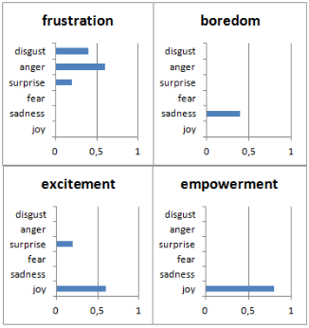

Figure 1 – Ekman’s Six Basic Emotion Model

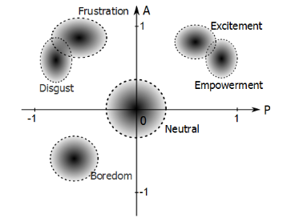

Figure 2 – Whissel’s Wheel Emotion Model

An additional study which involved post hoc analysis of recordings from usability tests was performed. This was to assess the practical applicability of the emotion recognition techniques in a real-world environment. The tests varied in that some participants used a mouse and keyboard and other participants used a touch screen. The instructions were provided on paper and the participants would look away from the camera to look at the instructions. This disturbance meant that the facial expression recognition with the use of the camera was not effective during those times. Some participants covered their face with their hand as much as 33% of the time which interfered with the facial expression recognition. The camera was located below the screen.

In conclusion, this research paper provided insight into the various means of detecting emotions and representing the data. The facial expression recognition technique of obtaining data is vulnerable to interference, however, it provides medium to high accuracy in detecting the emotion. The 6 basic emotions can be combined in various ways to form more complex emotions such as frustration and boredom. This could be useful in providing the researchers who will use the *UsabCheck* application with more intuitive data.

Esterwood (2018) [7] discussed how facial expression recognition technology can be applied to usability testing. They looked at journey maps as a way to display emotion data. Journey maps (See Figure 3) track the user as they move through the task and displays the user’s emotions along with the task they are trying to complete. Figure 3 illustrates the journey map they used in their explanation. Negative emotions of anger and sadness were assigned a -1 value and surprise and happiness were assigned +1 value on the y-axis. The time is plotted on the x-axis and the tasks are separated using a dotted line. The chart plots the emotions in a way that is either positive or negative which is indicated by an incline or a decline respectively.

However, this chart does not display exactly what emotion was experienced which makes this approach debatable. Surprise was also marked with a +1 value which is the same as happiness and carries the assumption that the user’s surprise is a positive thing. One might argue that for a system to be usable the user should not much experience surprise and user surprise can be the result of bad design.

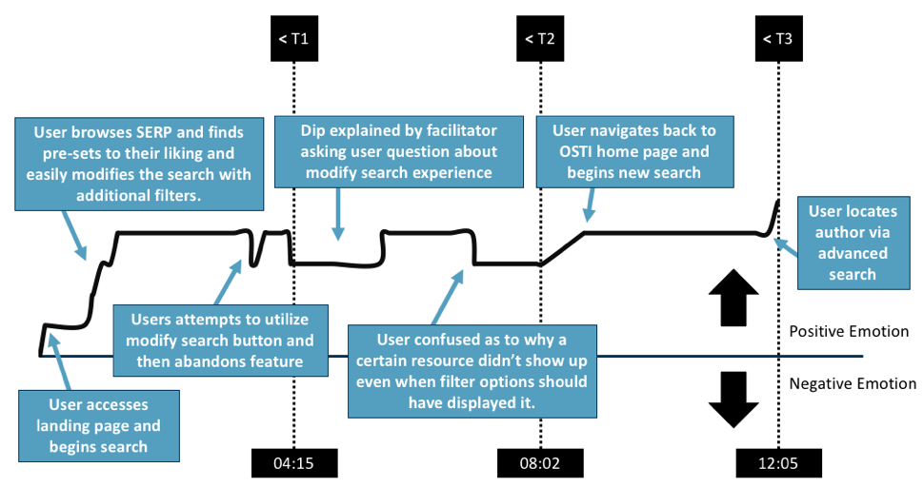

Figure 3 - Example Journey Map

The recommendations by the study for future studies is to ensure that users are limited to a strict time limit as a way to allow for averaging of emotional states and combining them into one journey map. Another recommendation is to have a camera exclusively for the face. In conclusion this study has provided insight into displaying the emotion data in the context of usability testing that is visually easy to understand. However, the simplicity might be a disadvantage as the chart only works with positive and negative values and the value each emotion should be assigned is up for debate.

The recommendation to limit the amount of time the user is allowed to spend on a task as a way of better average the emotional states of several participants is very insightful. Users of varying degrees of ability will spend different amount of time on each task and averaging the emotional states to be displayed on a journey map is definitely challenging. Reducing the amount of time, the user can spend on a task can help with that. However, that length of time is subjective to the researcher conducting the usability test.

### 2.1.2 Facial Expression Recognition Research

Halder *et al.* (2016) [8] proposed a prototype system which classifies the six basic emotions such as happiness, sadness, anger, fear, surprise, and disgust. They explored a new approach to the emotion classification of facial expressions by combing a neural network-based approach with image processing. The system includes face detection and feature extraction for emotion classification. The feature extraction involved locating the eyebrows, eyes and mouth regions. The image processing techniques included the use of edge detection, for example, Sobel edge detection which finds edges by the gradient changes in an image. These features have points and these points are processed to obtain inputs for the neural network. The results of the classification were left out of the research paper since the network is still being tested. Despite the lack of results, the research has provided insight into facial expression recognition classification and shown that image processing techniques can be useful should that route be taken.

Gaurav (2018) [9] wrote a case study that discussed real-time facial expression recognition with deep learning. The case study outlined the objectives and constraints associated with facial expression recognition. Accuracy is a constraint in deep learning models, the higher the accuracy the better the model will perform in the application and the less errors it will make. The case study also outlined three performance metrics that can be used in the evaluation of the deep learning model. These are the *Multi-Class Log-loss*, *Accuracy*, and *Confusion* *Matrix*. These performance metrics will be discussed on their own in another section of the research document. The model was trained on both human faces and faces of animated characters with an approximate ratio of 1:9. The cross-validation accuracy on animated characters was 100% and 87% on human images. The VGG-16 convolutional neural network was used and this architecture will be discussed in detail in another section of the report. A combination of 3 human face expression datasets were used as some datasets were not large enough. In total there was approximately 1,500 human images and 9,000 animated images.

The confusion matrix in Figure 4 below displays the results tested on the human data. The predicted class is plotted on the x-axis and the true values are plotted on the y-axis. E.g. The “Angry” class was predicted 25% (11/44) of the time when the actual class was “Disgust”. The model often predicted “Angry” when presented with negative face expressions such as disgust and sadness.

In conclusion this case study has provided a lot of value to this project as it introduced many aspects of deep learning which includes the datasets, training, validating, testing the model, and performance metrics for evaluating the model and the neural network architecture. These served as a starting point for further research. This case study also proved that animated images may be used to help create a facial expression recognition model that can classify facial expressions of real people.

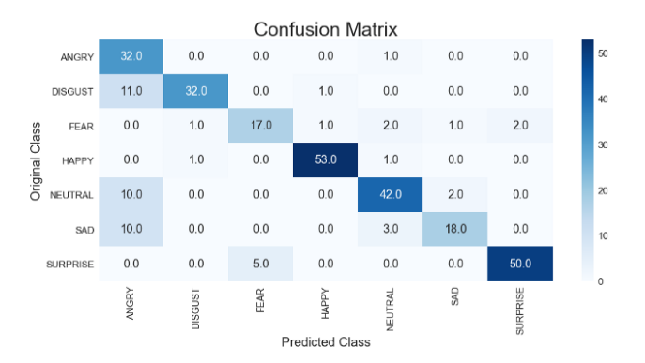

Figure 4 - Confusion Matrix Example

### 2.1.3 Usability Testing Research

Bastien (2009) [10] reviewed the methods and procedures in usability testing. The usability testing applications the research is based on are in the field of medical and healthcare informatics. *UsabCheck* will be designed to allow usability testing on virtually all desktop applications, meaning this research is relevant. They discussed the previous research on remote usability testing. Usability testing in a lot of cases involves the researcher/evaluator inviting the participant to their research facility and the participant completing the tasks in a test room. This room would contain the equipment to record the participant completing the tasks. For example, the recordings can be visual or/and audio. In remote usability testing the participant and the researcher are not in the same location.

Remote usability evaluation can be synchronous, meaning that researcher can manage the usability test in real-time and the interaction between researcher and test participants can be facilitated with conferencing applications. Usability evaluation can also be asynchronous, meaning that the observers/researchers are not present during the test and cannot interact with the participant as they are completing the tasks. The advantage of remote asynchronous evaluation is that many usability tests to be conducted at one time in parallel and recordings and data collected can be evaluated at another time. For example, the participant will download software onto their machine that will give them instructions for conducting the usability test.

The disadvantage of asynchronous testing is that the user’s equipment such as the microphone and camera need to be of a certain standard to collect the data accurately. Variables such as lighting conditions can reduce the accuracy of the facial expression recognition algorithm. This research has provided valuable insight into conducting usability tests and raised questions to be discussed when designing the *UsabCheck* application with regards to remote testing.

### 2.1.4 Machine Learning Research

In the previous section, machine learning model evaluation metrics were mentioned which included the confusion matrix. In this section the confusion matrix and other related machine learning model evaluation metrics will be discussed in detail. The article by Narkhede (2018) [11] explains the confusion matrix and how the values can be used to calculate precision, recall, accuracy, specificity and the AUC-ROC curve. Referring to Figure 5 for the following explanation of the confusion matrix, the cell where the row and column with the same label match is the “True Positive” value. In other words, the value which represents the model guessing correctly. The “True Negative” value is when the model has predicted correctly that the result is negative. The “False Negative” value is when the model wrongly predicted “negative” when it should have predicted positive. The “False Positive” value is when the model wrongly predicted a value as positive when it should have predicted a value as negative.

To put the theory into context of emotion classification we look at the “Angry” label in Figure 6. Outlined in green is the correct predictions made by the model. The x-axis label and y-axis label for that cell are both “Angry”, meaning that the model predicted “Angry” and the true label was “Angry”. The cells within the column that are outlined in red and shows the number of times “Angry” has been predicted when the actual label was not “Angry”, for example, “Disgust”. The cells outlined in orange show the times when the model wrongly classified “Angry” as another class. E.g. The emotions was classified as “Neutral” when it was “Angry”.

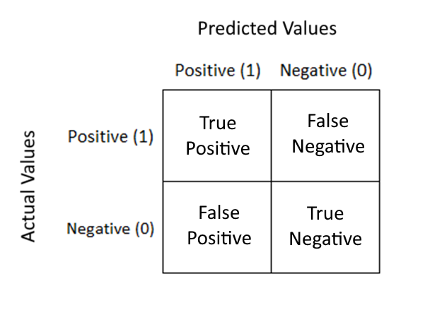

Figure 5 – Confusion Matrix Labels

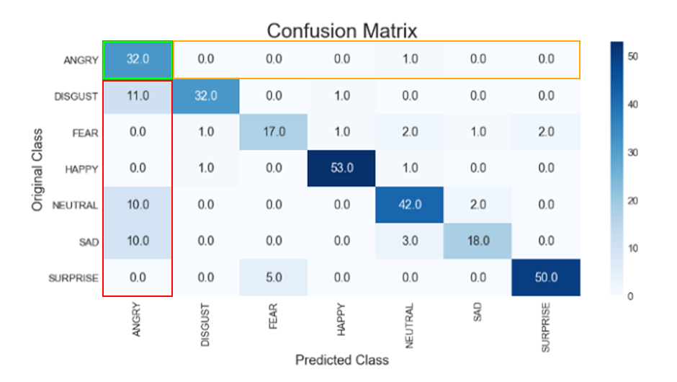

Figure 6 – Confusion Matrix

The article by Koehrsen (2018) [12] explains in detail the classification metrics of recall, precision, accuracy and the F-measure. Accuracy on its own is not a good enough metric to determine if the model is useful in the scenario that the sample size is large and the ratio of the classes is extremely uneven. This is known as the imbalance classification problem. The metrics need to be balanced and tailored to the application. Increasing the recall means decreasing the precision and vice versa. Depending on the type of application, the design decision might be to increase precision over recall or recall over precision and this will be considered in the design of the *UsabCheck* application.

The *Recall* is the ability of the model to correctly predict.

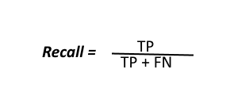

The *Precision* calculates how many positive classes were actually positive.



The *Accuracy* is how much out of all the classes have been predicted correctly.

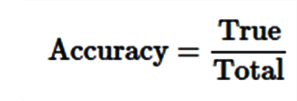

The *F-measure* combined the recall and precision values to more easily compare two models with high recall and low precision and vice versa.

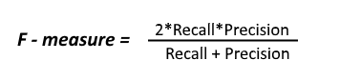

#### 2.3.1.1 Convolutional Neural Networks (CNNs)

Convolutional Neural Networks (CNNs) are a type of Deep Neural Network (DNN) and can efficiently and effectively be used to perform numerous tasks that involve pattern and image recognition. These tasks include object recognition, hand gesture recognition [13] and face recognition [14], to name a few. CNNs may be used for image segmentation, classification and retrieval with high accuracy. For example, a CNN trained on the MNIST (handwritten digits dataset) has achieved a detection rate of 99.77% [15] which shows how effective CNNs in image classification.

A CNN consists of layers and these layers include, the input layer, convolutional layers, pooling layers, rectified linear unit layer and a fully connected layer. The input layer is the first layer that takes in the input data. The convolutional layer applies filters to extract the features from the data and a CNN may involve the use of many convolutional layers. The extracted features are passed to the pooling layer which reduces the size of the images. This preserves the most prominent features which are extracted. The Rectified Linear Unit Layer (ReLU) is an activation function that replaces any negative number in the pooling layer with zero. This keeps the CNN mathematically stable and prevents the vanishing gradient problem when the number of layers increases [16]. The fully connected layer is the final layer and uses the results from the previous layer to classify an image [17][18].

#### 2.3.1.2 VGG Model

The VGG-16 Model [19] is a famous CNN model that achieved a 92.7% test accuracy in the ImageNet dataset [20], making it the winner of the ILSVRC (ImageNet Large Scale Visual Recognition Competition) in 2014 [21]. The dataset the model was trained on consisted of 14 million labelled images belonging to 1000 classes [22]. This model can be used to train a facial expression recognition model as shown by Kusuma *et. al* 2020[23]. They used a fine-tuned VGG-16 model on the FER2013 dataset and achieving an accuracy of 69.40%, outperforming most standalone-based model results. The architecture with the layers mentioned is illustrated in Figure 7.

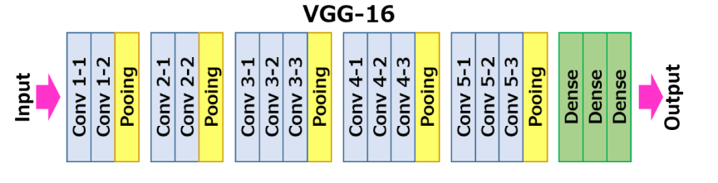

Figure 7 – VGG-16 Architecture

#### 2.3.1.3 Support Vector Machines (SVM)

Support Vector Machines (SVMs) can be used for both regression and classification tasks. The algorithm works by finding a hyperplane in an N-Dimensional space where N represents the number of features. The hyperplanes separate the data points and the optimal hyperplane has a maximum margin between the data points of the classes. The accuracy of the algorithm depends on the hyperplane to separate the classes. In other words, the smaller the margin the more difficult it is to classify the data points as belonging more to one class than the others [24].

In the scenario that the data points are not linearly separable, the SVM kernel trick can be used. The concept behind the kernel trick is to map the dataset into a higher dimensional space which enables the algorithm to find a hyperplane that can separate the data [25][26].

#### 2.3.1.4 Bag of Visual Words (BOVW)

Bag of Visual Words is commonly used in image classification. The concept is similar to the Bag of Words (BOW) in natural language processing. In BOW the frequency of the words is obtained and can be displayed on a histogram. In BOWV, instead of counting the frequency of words in a given text, the image features are counted and can be displayed in a similar fashion using a histogram. Image features consist of a keypoint and a descriptor. Keypoints are segments of the image that stand out and this can be determined by the corners and edges in the image. These keypoints do not change even if the image is resized or rotated. The descriptor is the description of the keypoint.

The descriptors are clustered with a clustering algorithm. An example of a clustering algorithm is K-Means clustering and the center of each cluster is the visual “word”. A histogram is generated for each of the training images which is later used in the classification of a new mage. An example of this histogram is illustrated in Figure 8. To classify an image the features are first extracted, then plotted on a histogram and compared with the visual words’ histogram from the training set [27][28].

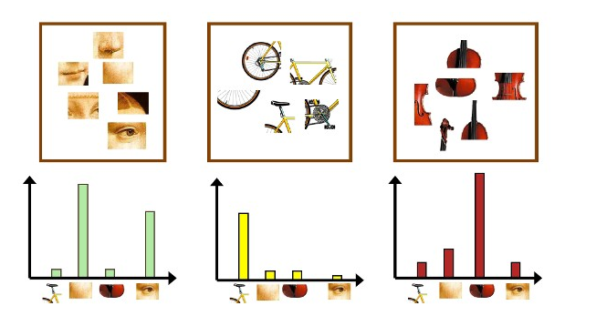

Figure 8 – Bag of Visual Words Histogram Example

#### 2.3.1.5 Face Detection

Several methods for face detection are discussed in the article by Dwivedi (2018) [29]. The methods for detecting a face can be feature-based, appearance-based, knowledge-based and template matching.

Feature based methods detect the face by extracting features of the face such as the edges and corners in an image. In other words, it looks at the structure of the image and involves training a classifier that can tell the difference between an image that contains a face and one that does not. This method performs very well with an accuracy as high as 94%. An example of this method is the Haar Cascade features algorithm. It is an object detection machine learning algorithm and can be used for face detection with high accuracy. A pre-trained Haar Cascade for frontal face detection can be easily implemented.

An appearance-based method involves training a machine learning algorithm to learn the characteristics and patterns of a face. The data is presented to the algorithm that has no prior knowledge and through statistical analysis it learns what a face looks like.

Knowledge-based methods detect the face in the same way that a person would describe a face. In other words, there is a set of rules that determine if the image is of the face and these rules can include the presence of a mouth, nose, eyes etc. of a certain size and relative position. For example, the mouth is below the eyes. This approach on its own is not sufficient enough to consistently detect faces in images.

Finally, a template matching method uses a pre-defined face template to detect the faces by checking how closely the input image matches the template. Although this method is easy to implement it is not sufficient enough for consistent and accurate face detection. Deformable templates can help with increasing the accuracy of the method.

In conclusion, the method chosen for face detection was the Haar Cascade algorithm as it is very effective and the implementation is simple as the model is already pre-trained.

### 2.3.2 Dataset Research

#### 2.3.2.1 JAFFE (The Japanese Female Facial Expression (JAFFE)

The JAFFE dataset [30] consist of labelled images of the frontal face. The facial expressions in the dataset are from 10 people, all of whom are Japanese and female. There is a total of 213 grayscale 8-bit images and the image resolution is 256x256 pixels. The facial expressions are labelled with anger, disgust, fear happy, sad, surprise, and neutral. For a high accuracy model, a total of 213 images is not sufficient on its own and data augmentation techniques will have to be used to generate more images from the existing set to increase the amount of data.

#### 2.3.2.2 FER2013 (Facial Expression Recognition Dataset 2013)

The FER2013 dataset [31] is in the form of a .CSV file and consists of 28,000 labelled images in the training set, 3,500 images in the validation set and 3,500 images in the test set. The images are stored in the file as an array of pixel values which can used to reconstruct the image to a .jpg or .png format should the need arise. The images are labelled with one of seven emotions which are happy, sad, angry, afraid, surprise, disgust and neutral. All images are grayscale and of 48x48 pixel resolution.

#### 2.3.2.3 AffectNet

AffectNet [32] is one of the largest datasets for facial expression recognition and consists of more than a 1 million images with approximately 440,000 of which are manually annotated. The publishers of the dataset are experiencing issues with bandwidth as a result of many downloads meaning the request for the dataset is delayed and a response is yet to be received. The sample images appear to be of the face only and the very large quantity of images would mean a higher accuracy of the FER model.

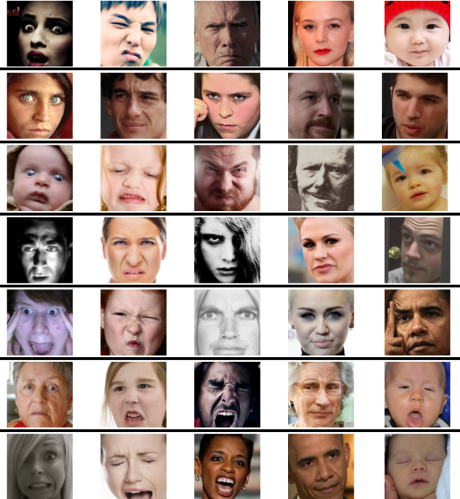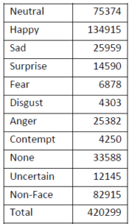

Figure 9 – AffectNet Dataset Info Figure 10 – AffectNet Sample Images

#### 2.3.2.4 FacesDB

The FacesDB dataset [33] consists of 38 individuals who are both male and female and each individual makes one of each face expression of joy, sadness, fear, anger, disgust, surprise and a neutral face expression. This means that there are only 38 images for each face expression and these images are of the frontal point of view with side views of the face explicitly labelled. Due to the quantity of images the dataset images will have to be augmented to generate more.

#### 2.3.2.5 FEC (Goole Facial Expression)

The FEC (Google Facial Expression Comparison dataset) [34] is in the form of a .CSV file. The dataset consists of face image triplets with each row in the file containing three faces. It is also specified which of the two images in the triplet contain the most similar face expression. Each image in the dataset was rated and annotated by at least six people. The dataset itself consists of approximately 500,000 triplets and approximately 156,000 face images. The images can involve people doing activities which is unlike some of the other datasets which only include the head. In the CSV file the image, four coordinates are provided that form a bounding rectangle that locates the face which allow for the face to be extracted from the image.

As the dataset is in the form of a .CSV file with links to the image, these images that have be downloaded and cropped using the bounding rectangle coordinates. The process by hand is simply unfeasible and a GitHub repository under the name “FEC Dataset Downloader” [36] was discovered for an application that was said to download all the images from this particular dataset automatically. However, that application used another application under the name “TorCrawler” [37] that was in nature of a web crawler and utilized the TOR browser to rotate the IP address. The TorCrawler functionality was said to be necessary as the dataset image downloads apparently stall after a while if the IP address is not rotated. The TOR Crawler application included instructions that assumed the operating system used was UNIX which meant the instructions could not be followed as the operating system used is Windows 10.

A decision was made to write a program that will attempt to simply pull down the images without the changing of IP addresses which has been successful and performed well. However, after further inspection the images may not be entirely suitable to the usability testing scenario as the images of the faces are taken at many different angles which may reduce the accuracy of the model. In a usability testing scenario, the environment is not going to be “natural” in that the scene is not expected to constantly shift and change as it would if the person was in a bustling area with many objects. The camera will be in a static position and the angle of the participant in question is unlikely to greatly vary. An example of an image is displayed in Figure 11.

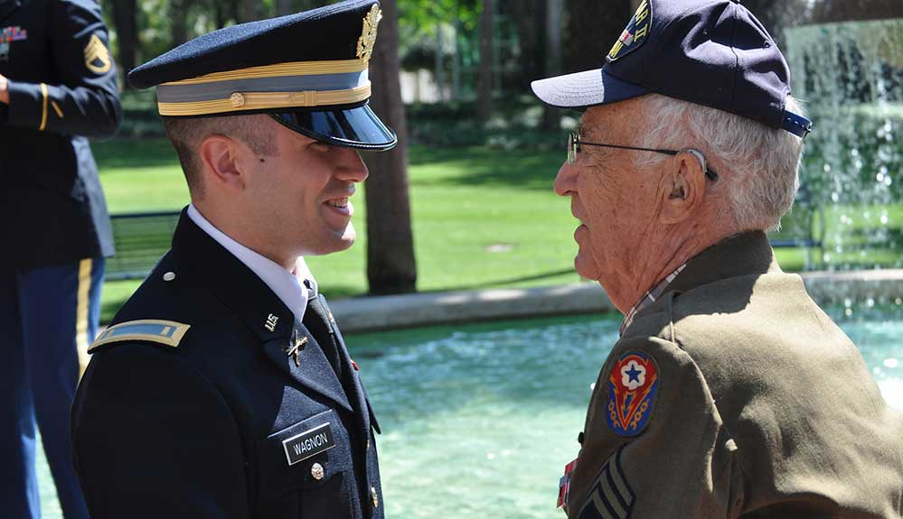

Figure 11 – Example of FEC Dataset Image Taken at Angle

#### 2.3.2.6 Emotic (Emotions in Context)

The Emotic dataset [35] is similar in nature to the FEC Google dataset and exclusively focuses on images of people in real environments. The images are annotated from a list of 26 discrete categories such as peace, sympathy, anger and surprise to name a few. The annotation are not simply for the face but also include the body. The angle at which the images are taken at and the fact that the focus is not only on the head might pose problems if used to train a facial expression recognition model. This dataset, as the name suggests, focuses on the context which is not a concern in a controlled usability testing environment.

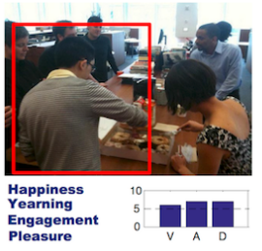

Figure 12 – Emotic Sample Image

#### 2.3.2.7 Conclusion

In conclusion, several facial expression recognition datasets have been researched and analysed. Certain datasets such as the FEC dataset and the Emotic dataset were not applicable in the usability testing environment. Other datasets such as JAFFE, FER2013 and FacesDB datasets were perfect for the training of the model in terms of the types of images. However, the JAFFE dataset and FacesDB dataset will require image augmentation to increase the dataset size. The AffectNet dataset is perfect in terms of both the types of images and the amount of images. However, as a result of these desirable features, the dataset is in high demand and the researchers who have published it are struggling with download bandwidth, meaning I could not acquire the dataset.

## 2.2. Alternative Existing Solutions to Your Problem

### 2.2.1 UserZoom Go

*UserZoom Go* [38] is a website usability testing application in the browser. It has a clean and easy to understand user interface. The researcher can create a “study” which is a usability test. There is an option to create an unmoderated or a moderated study and these studies can be conducted on own users or paid users can be selected based on a desired demographic based on age, gender etc. The application also provides support for both desktop and mobile applications.

The researcher can then create tasks and questions for the user to fill out and complete. These question answers include plain text, a multiple-choice selection and a rating selection. Questions may be asked before, during or after the study. Once the user begins the test, tasks will be displayed in a small window on screen and the user will click the “Complete” button whenever they are done with the task and move on to the next one. The user’s screen, audio and camera may be recorded depending on the usability test specifications. Once the test is over the data will be uploaded automatically and the researcher can view the recordings. The tasks are then reviewed and graded by the researcher with either a “Pass” or a “Fail”.

In conclusion, the website is very well designed and implemented. However, this comes at a starting cost of $250 a month for a basic plan which allows only 1 researcher seat and 15 studies per year. The displaying of data could be greatly improved upon as there is no charts that intuitively display the data and no averaging of data is done to provide a general overview. Despite these shortcomings the application is visually appealing and provides the features that make it complete in many aspects.

Figure 13 illustrates the dashboard, this is the main screen the researcher will see when the login. The view of the participant when they begin the test is displayed in Figure 14. Finally, the results of the usability study are shown in Figure 15.

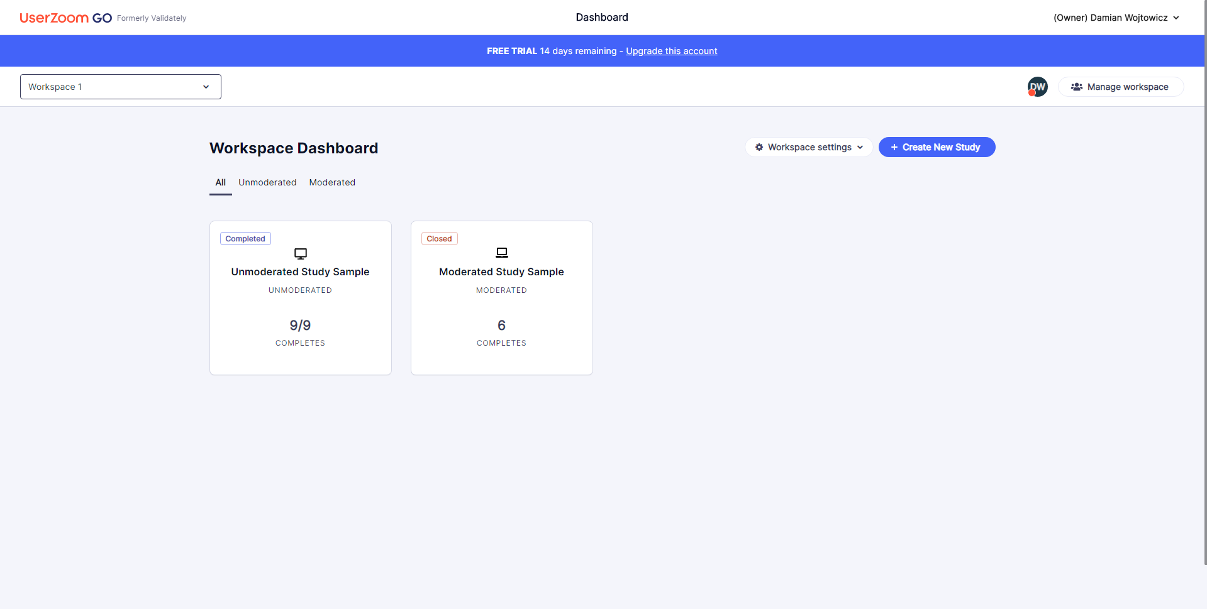

Figure 13 – UserZoom Go Dashboard

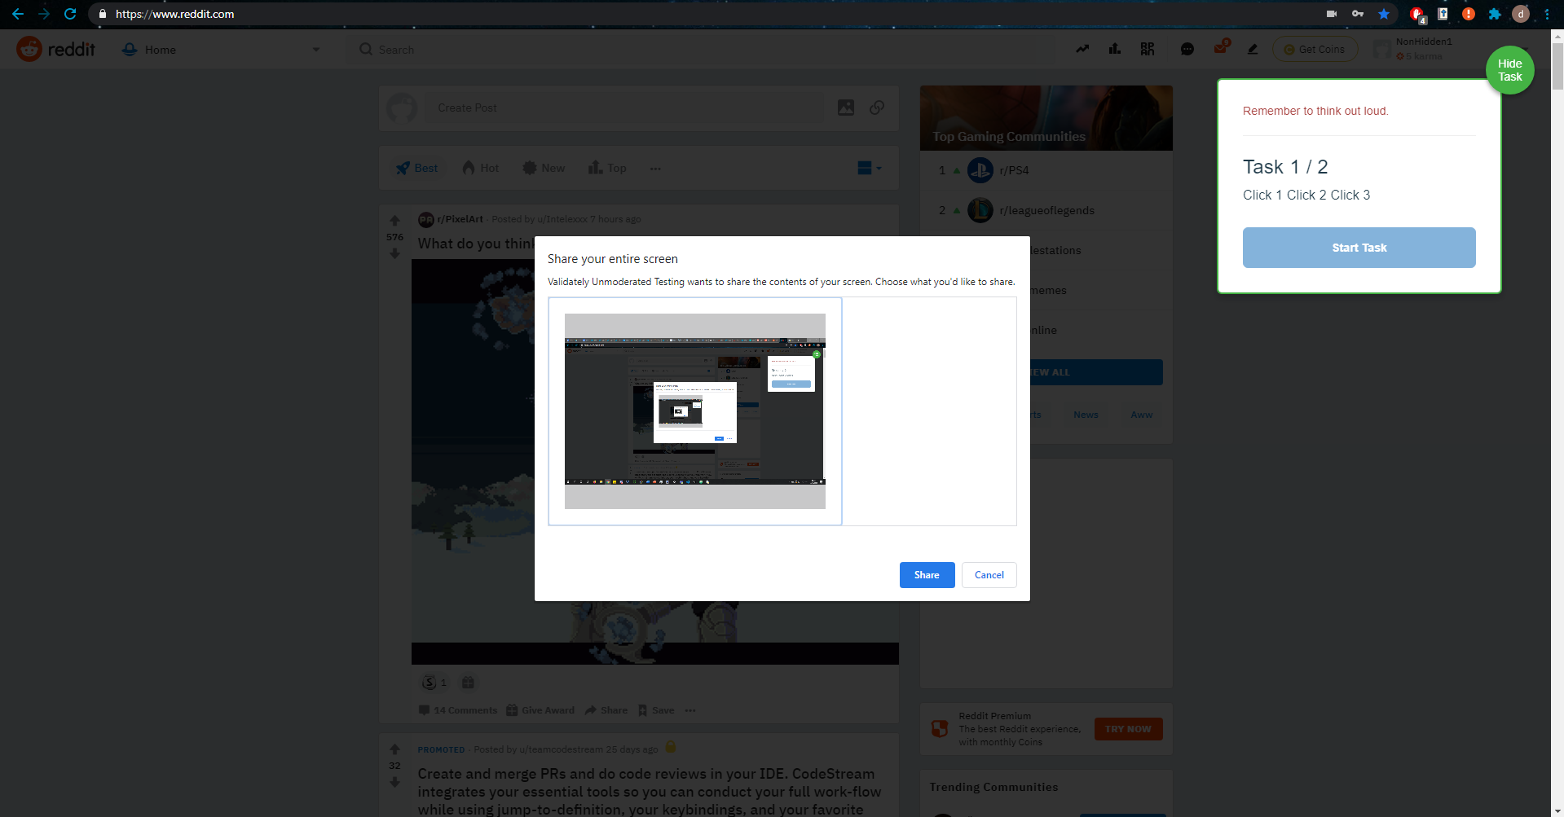

Figure 14 – UserZoom Go Usability Test Start

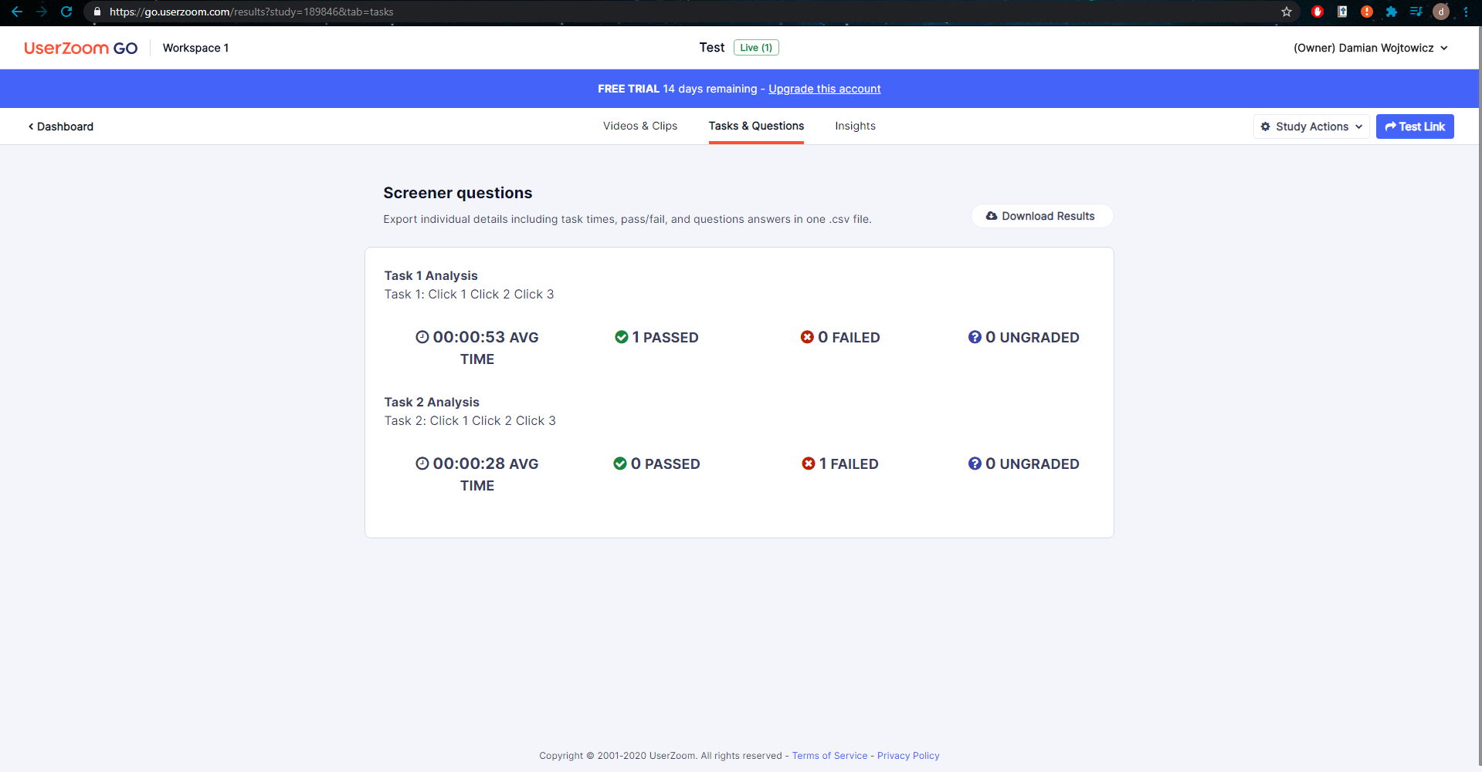

Figure 15 – UserZoom Go Usability Study Results

### 2.2.2 UserTesting

*UserTesting* [39] is a website usability testing application in the browser. The application that records the screen and the audio has to be downloaded. The user interface was a somewhat disorientating at first as there was a draft test that was already predefined and the button to create a test had a price tag of $49 next to it. The steps to be taken from the dashboard (See Figure 16) were not obvious as the initial thought process was to create a usability test and launch it. However, the website suggested launching a draft test and creating a new test appeared to cost money.

Creation of a usability test for free was not an option, however for research purposes the test creation steps were taken before the payment. The test creation options included selecting the audience (See Figure 17) by demographic such as age, gender, income, country, employee status etc. The participant device selection was between a computer, a tablet and a smartphone. A scenario could be written for the participant before the test begins and pre-test questions could also be defined. The tasks are written in text and a 5 second task can be set up where a user will be shown a screen for 5 seconds and asked to describe what they saw. A verbal response question can be asked. Some question options such as a multiple-choice question, a rating scale and a written response required a premium subscription. The test creation screen is illustrated in Figure 18. There is an option to notify team members of the test results via Slack or email.

The website provided a usability test dry run from the participants point of view before a usability test is launched. This provided more insight into usability testing; however, the data was not recorded as it was simply a dry run which meant that seeing how the data is presented after the usability test has concluded was not possible without payment. In conclusion, the usability testing website provided a lot of options, some of which seemed unnecessary. For example, filtering the demographic by “Parental status”. Viewing the results of a test was impossible without payment despite the free trial and certain parts of the website were disorientating.

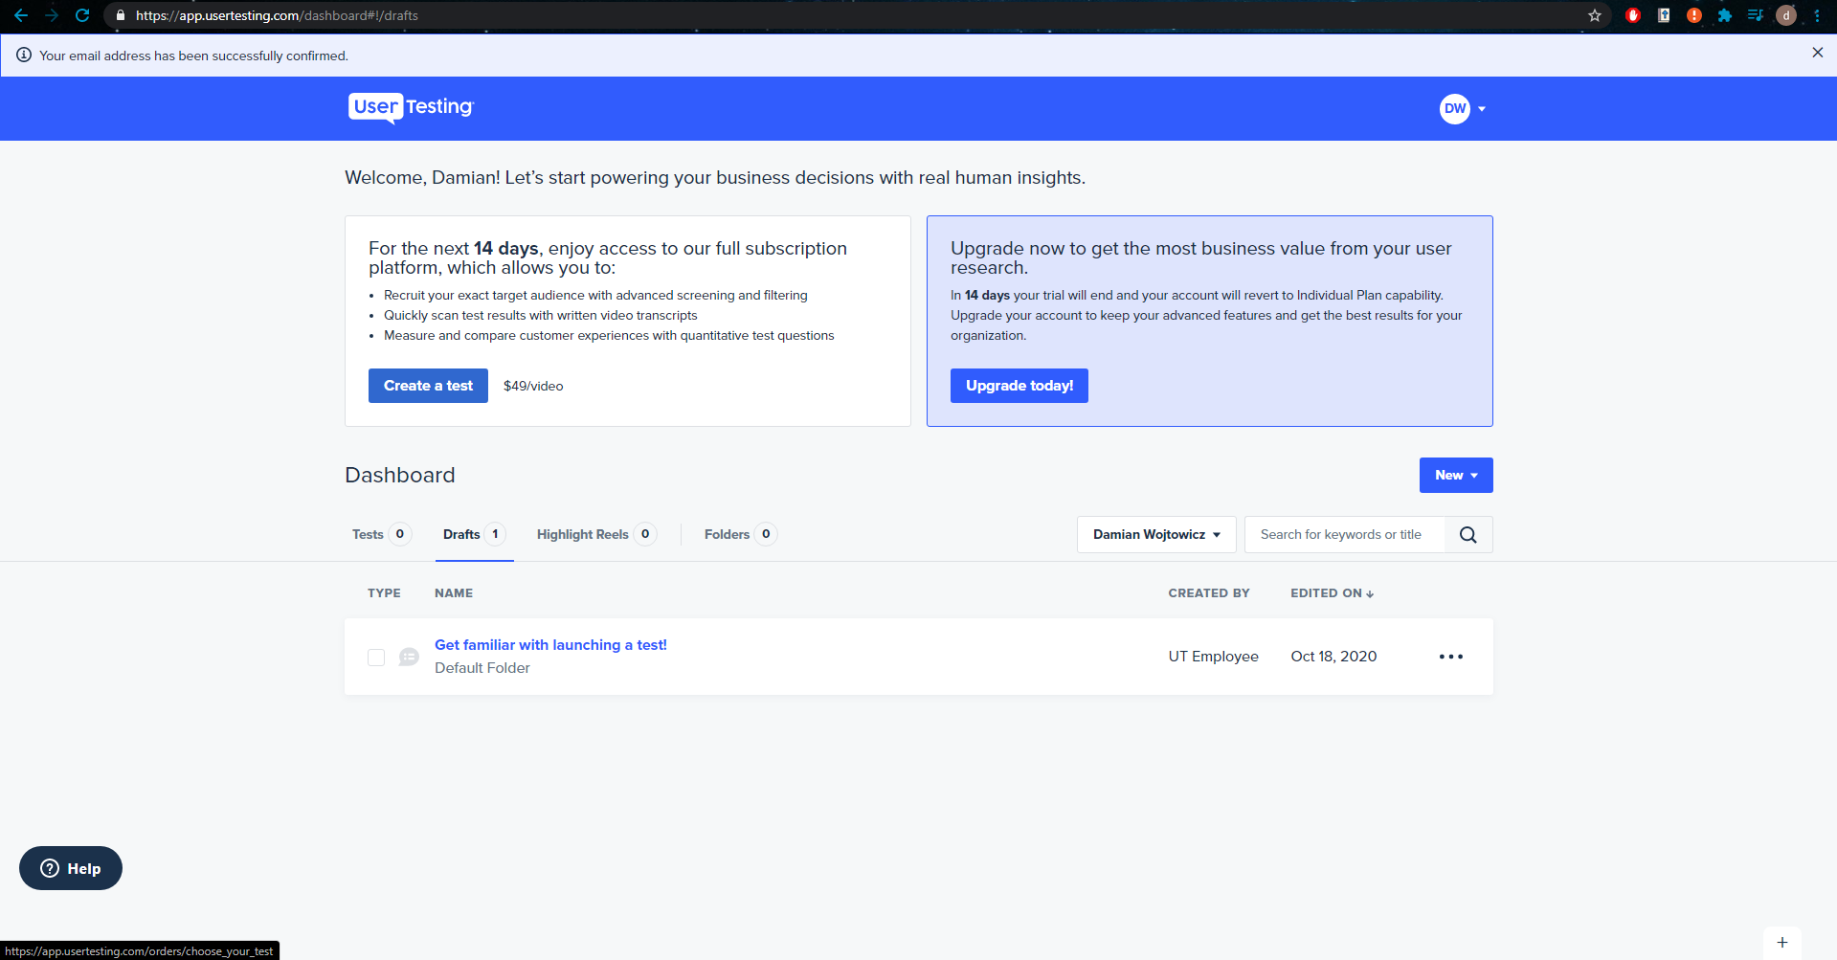

Figure 16 – UserTesting Dashboard

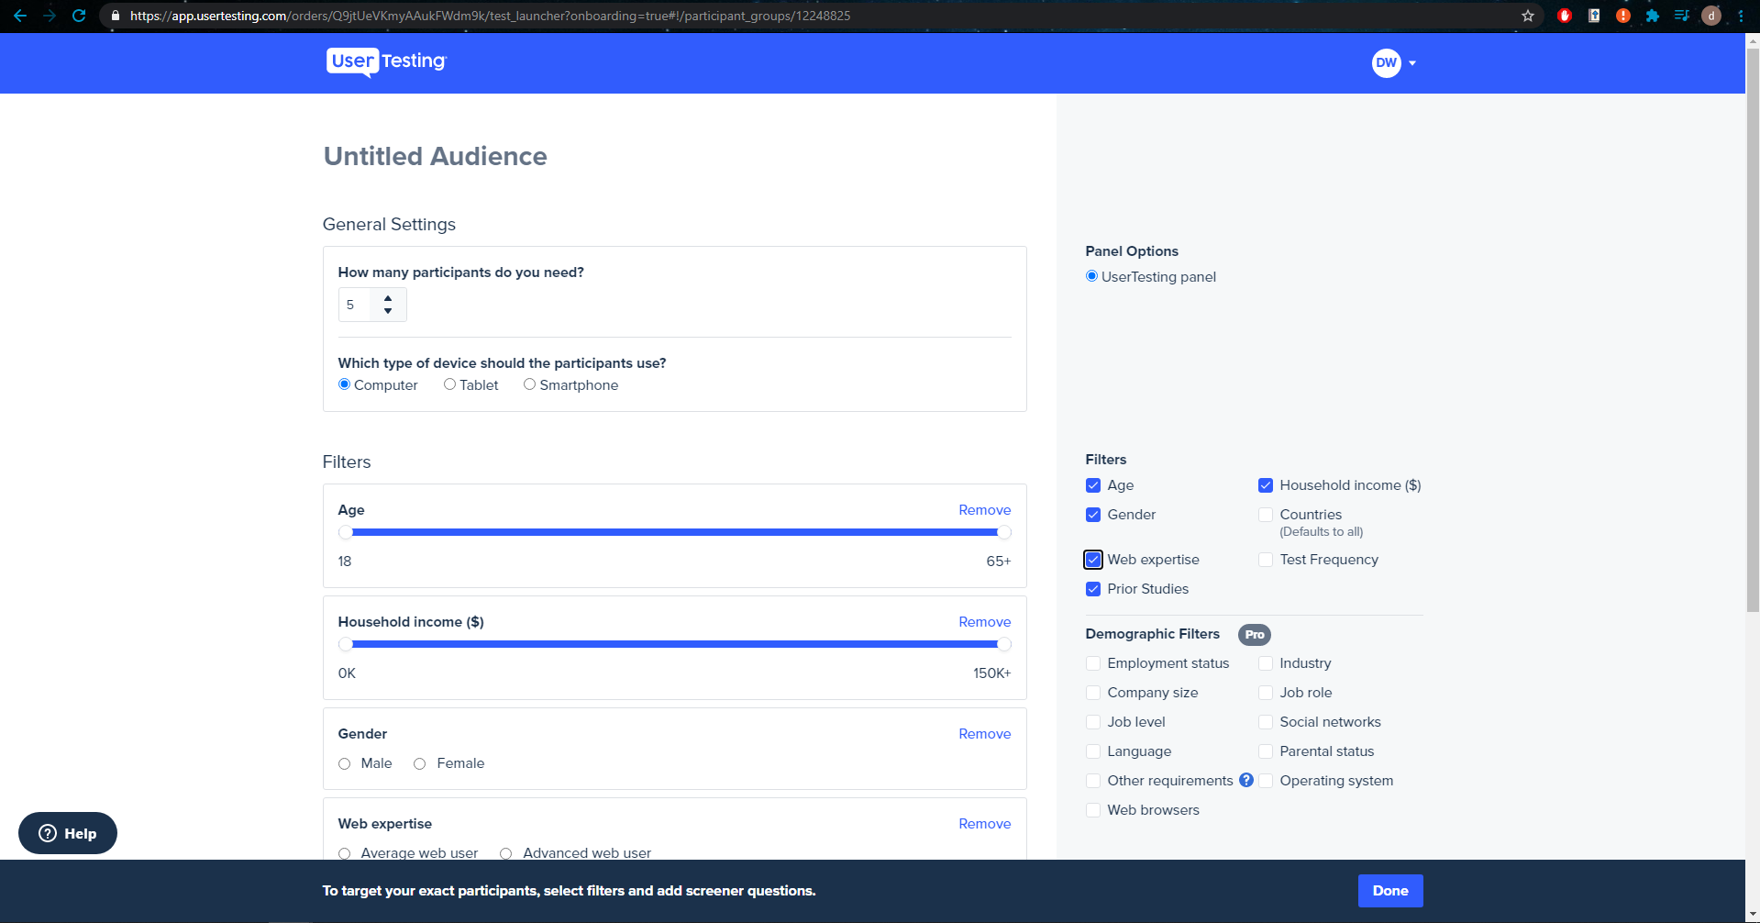

Figure 17 – UserTesting Select Audience

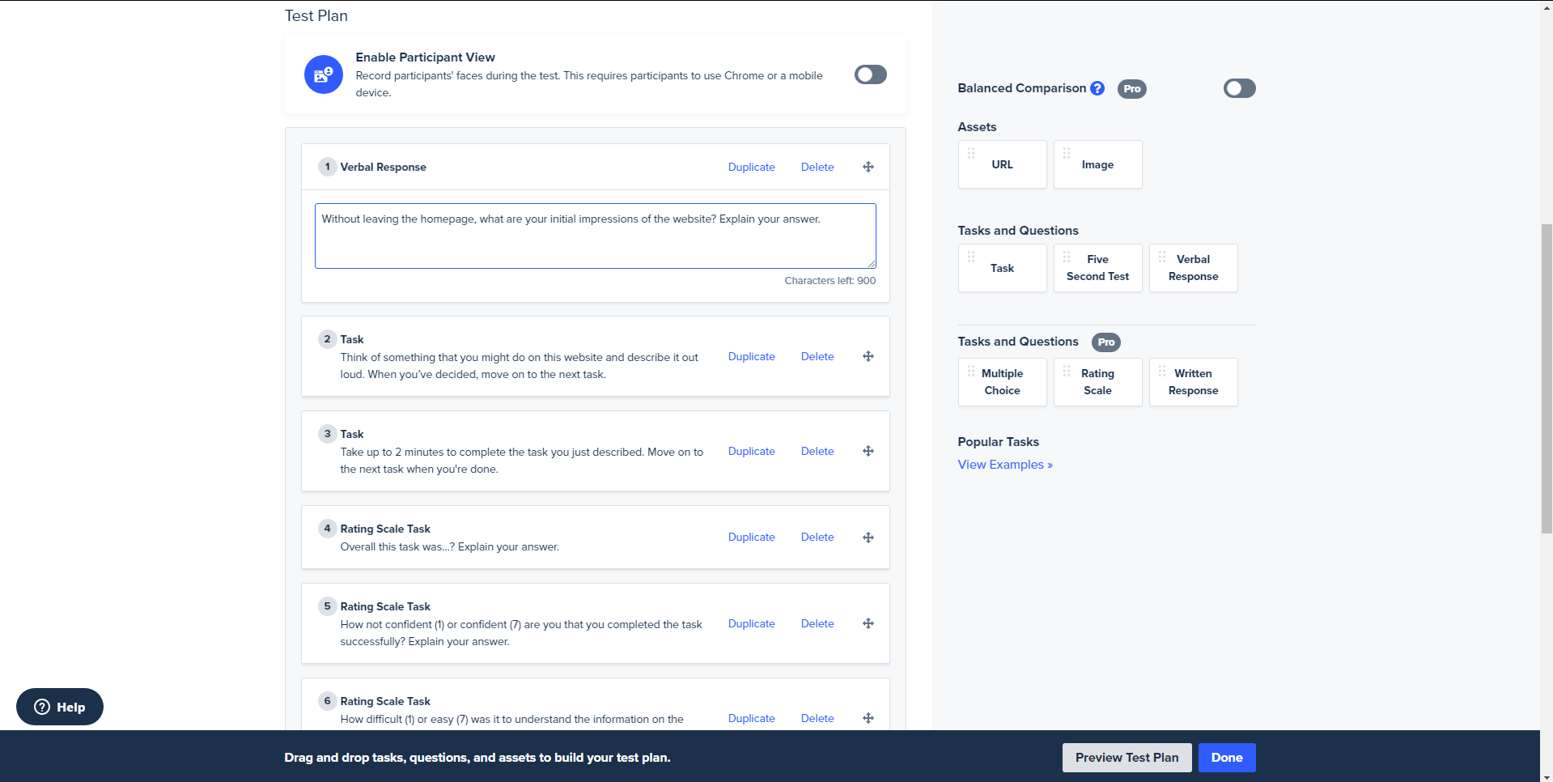

Figure 18 – UserTesting Create Usability Test

### 2.2.3 Loop11

*Loop11* [40] is a website usability testing application in the browser. The researcher can create a new “project” which is a usability test/study. These projects are listed in the main dashboard which is illustrated in Figure 19. Statistics and other information about the overall users’ performance is shown in the project overview along with pie charts that display the number of participants that have successfully completed the tasks, failed or abandoned the study. Information on the total number of participants and the average duration of the study is displayed. This is illustrated in Figure 20. More statistics about the participants is displayed such as their location, operating system, device and browser which can be seen in Figure 21.

The researcher can view the project in terms of the tasks, the videos, questions and participants. A tab is given for each of the mentioned. This allows for easy navigation which is definitely desirable in any application. The video of the participants completing the tasks and questions can be viewed. All the data on each participant can be displayed. A clicksteam & heatmap which is illustrated in Figure 23 can be viewed which shows how users progressed through the tasks in terms of the links they clicked on.

The tests can be moderated or unmoderated and there are options to enable or disable screen and webcam recording for the test. Tasks are written in plain text with the option to customize the text with fonts and font sizes. There is a wide selection of questions that can be selected from ask the participant and these are displayed in Figure 22. The questions include a multiple-choice question with one answer, a rating scale matrix, a ranking question and a multiple choice (multiple answers) question just to name a few. There are options to randomize the order of answers in a given question when applicable e.g. multiple-choice question.

In conclusion, this application has a modern design that is appealing to the eye and easy to use. Navigation is easy and the data is displayed in a presentable manner which includes charts. The clickstream is an interesting idea of tracking how all the users progressed in the task. However, an issue with the website is that the video quality was very low and would not load very fast.

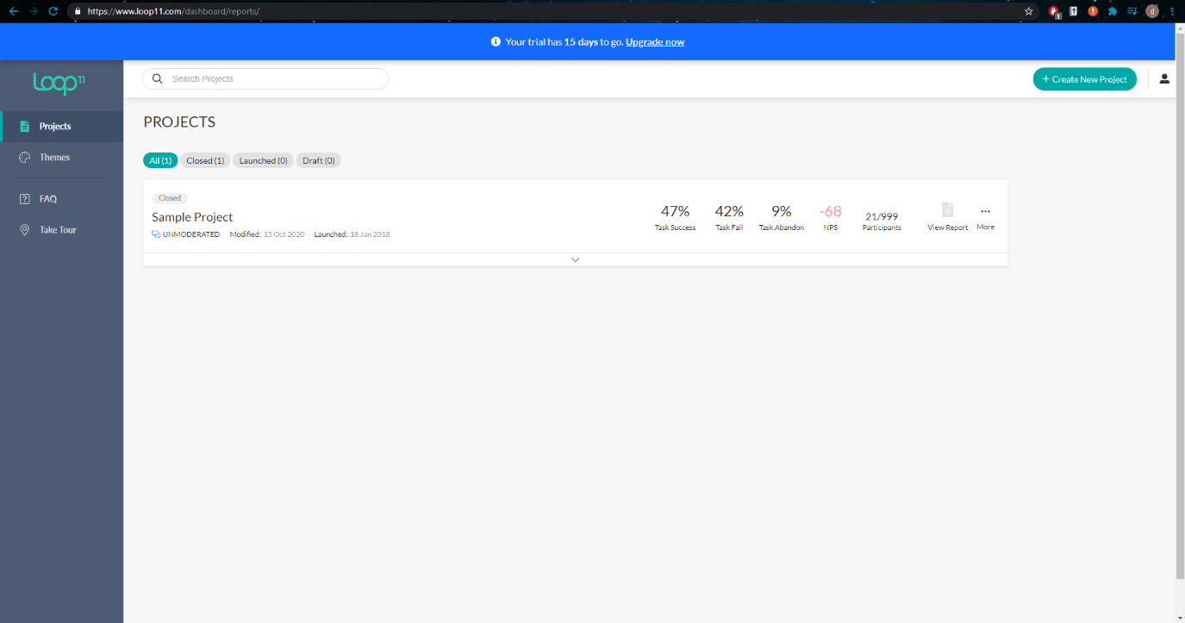

Figure 19 – Loop11 Main Dashboard

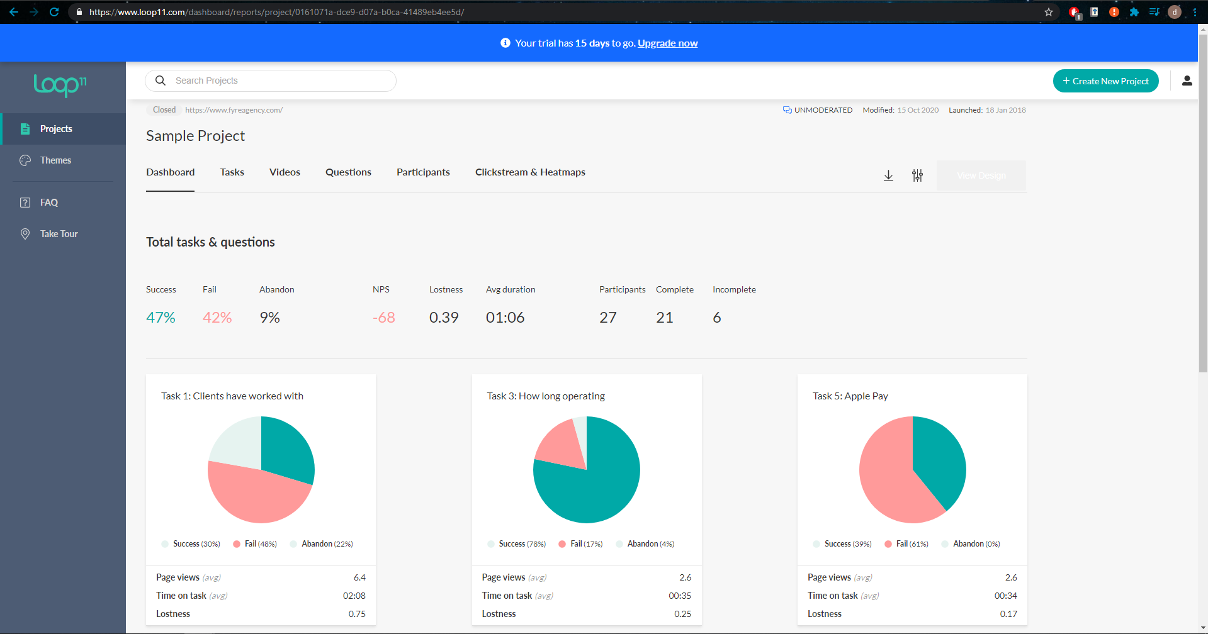

Figure 20 – Loop11 Project Dashboard

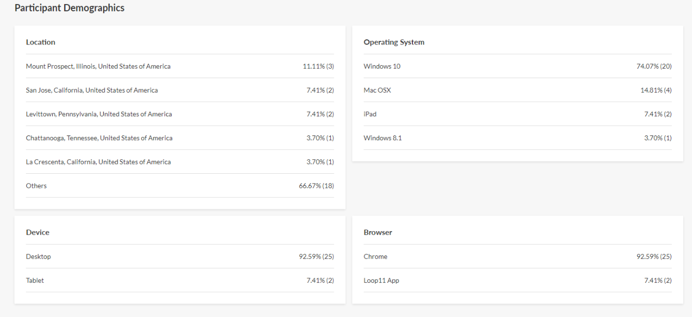

Figure 21 – Loop11 Participant Demographic

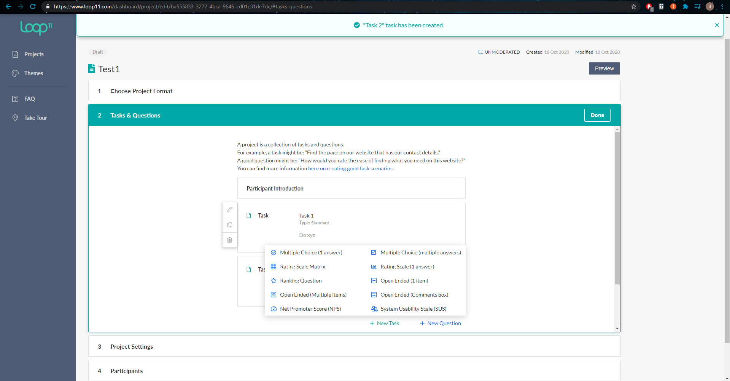

Figure 22 – Loop11 Tasks and Questions

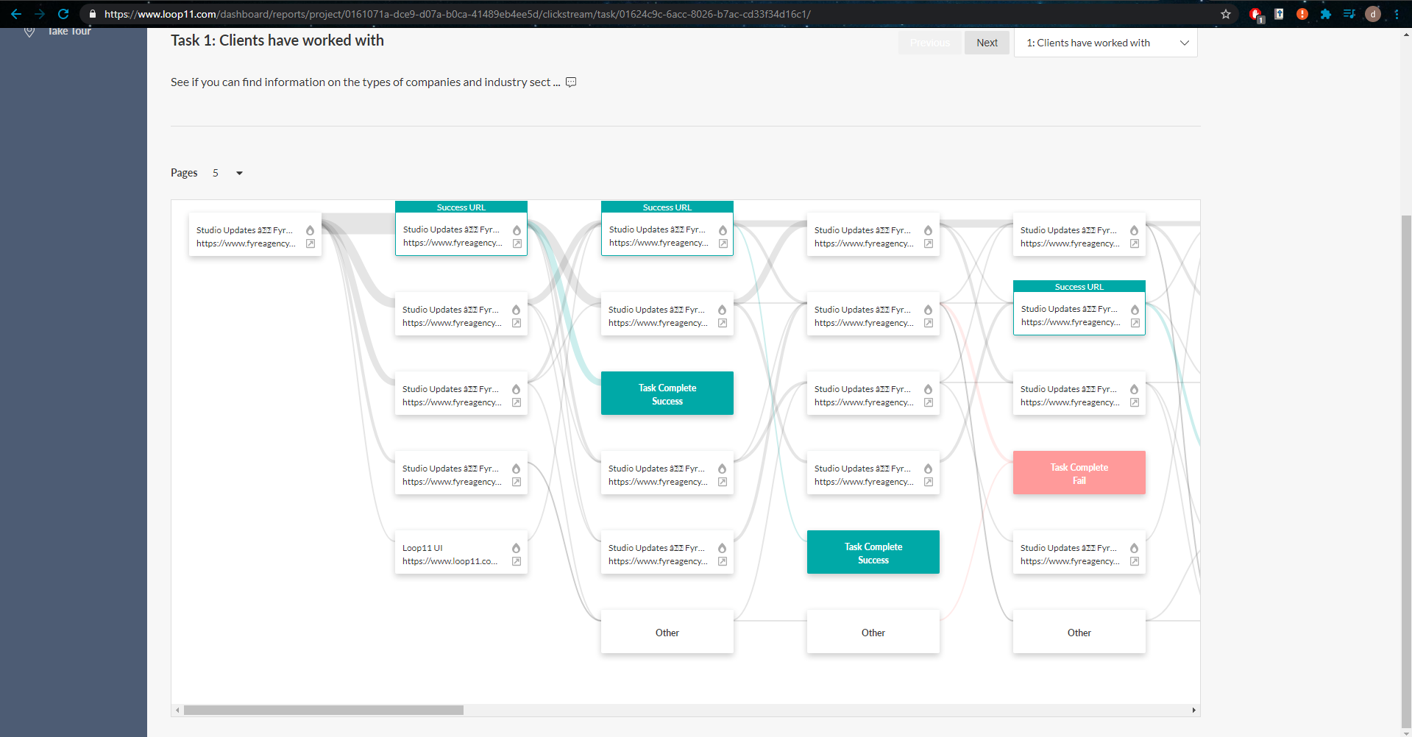

Figure 23 – Loop11 Clickstream

## 2.3. Technologies Research

### 2.3.3 Programming Languages

#### 2.3.3.1 Python

Python [41] is a high-level, interpreted, object-orientated and general-purpose programming language. Python supports a vast amount of libraries which includes machine learning libraries such as TensorFlow, Keras and Scikit-Learn, to name a few. The language is free, open source and cross platform. The programming language is popular and finding support online to questions is easy which greatly helps with the development process. The popularity of the language with regards to machine learning and data visualization makes it a very strong contender as a language of choice for machine learning [42].

Django [43] is an example of a high-level Python Web framework which allows for web development with Python. Django is integrated with JavaScript and HTML which means JavaScript code and functionality can be used in Django.

#### 2.3.3.2 Java

Java [44] is a class-based, object-oriented, platform-independent language. Java can be used to develop the server side of web applications and is the no. 1 choice for developers with over 9 million Java developers worldwide [45]. The popularity of the language and its use in web development makes it an excellent option for developing the *UsabCheck* web application’s middle tier. It is a programming language taught in the TU Dublin Computer Science course which makes it familiar and easier to work with.

#### 2.3.3.3 JavaScript

JavaScript [46] is an interpreted programming language that allows developers to implement complex and dynamic features on web pages. JavaScript compiles the code at run time with the use of a technique called *just-in-time compiling*. JavaScript can run locally on the machine of the user viewing the website and can be used for interaction with the back-end server via a Restful API. It can also run on a server in the middle tier and there is a back-end and front-end framework named Node.js [47] that can be used in the development. There are also front-end frameworks and libraries such as AngularJS [48] and ReactJS [49] in the scenario that the design plan will be to have a Java back-end instead of a JavaScript back-end.

### 2.3.4 Python Libraries

NumPy [50] is an open source library used for working with numbers, arrays, matrices, linear algebra etc. Images are simply matrices of pixel values and NumPy can be used to alter and manipulate these images.

Pandas (Python Data Analysis) library [51] provides functionality that can extract data out of a CSV file as an example and create data frames that are similar in structure to an Excel file in Python. This library can work with NumPy to manipulate the data.

Matplotlib [52] is a library that generates charts and other forms of data visualization in Python. These figures can be interactive and allow the user to zoom in and pan etc. on these figures. This library can be used to display images in Juypter Notebook and the results of machine learning algorithms can be displayed in various forms . For example, Matplotlib can be used to display a confusion matrix as an example.

Scikit-learn [53] is a machine learning library that includes other libraries such as NumPy, SciPy and Matplotlib to name a few. It is a tool for predictive data analysis and includes implementation of algorithms such as SVM, Nearest Neighbour, Random Forest, K-Means etc.

TensorFlow [54] makes it easy for developers to create and train deep neural network models for desktop, mobile, web etc. This library has many applications which include sound recognition, text-based applications, image recognition and video detection [55].

Keras API [56] is fully integrated with TensorFlow and serves as a wrapper for TensorFlow and Theano, providing a simple and intuitive interface for the machine learning libraries.

Fastai [57] is another deep learning library that provides its users with high-level components and it is GPU optimised just as the other libraries mentioned. An article [58] detailed the first impressions of the Fastai library and impression was that it is a good library to use. However, it comes with some slight learning curve drawbacks. The wiser decision would be to use TensorFlow and Keras to train the deep learning model as the two libraries are more popular and there is more online support as a result.

OpenCV [59] is a computer vision, machine learning and image processing library. It can be used to manipulate images which includes resizing, rotating, detecting edges, converting the image to different colour spaces etc. This library can be used in a hybrid approach to train a FER model whereby facial features are extracted with OpenCV and used to train a machine learning algorithm. This has hybrid approach has been researched by Halder *et al.* (2016) [8] and discussed in section 2.1.2.

## 2.4. Usability Testing Technologies

### 2.4.1 Usability Testing

The idea for the usability testing application is to create a web application that will store the data and allow researchers to configure the usability tests. For this goal to be achieved, video uploading and streaming has to be implemented and this may include a 3rd party service. The website has to be hosted and a database will have to be selected. The technologies for these requirements are listed and described below.

### 2.4.2 Video Uploading

Several video streaming services have been researched to find the most convenient method of uploading and streaming the videos reliably.

#### 2.4.2.1 SwiftStack

SwiftStack [60] is a data storage and management platform for data-intensive applications. It is easily scalable and supports HTTP Range requests which means that pseudo-streaming is supported. Pseudo-streaming involves downloading the file and playing that file as it is being downloaded. This is how YouTube streams their videos.

#### 2.4.2.2 StreamingVideoProvider

StreamingVideoProvider (SVP) [61] provides video streaming and other services. The videos uploaded can be embedded in the *UsabCheck* application. SVP provides video tutorials for how to use their services and a developer’s API for cURL, Java, PHP, Ruby, Python and JavaScript. The videos can be managed and statistics can be provided. The service provides far more other functionality than is needed for the *UsabCheck* application.

#### 2.4.2.3 Vimeo

Vimeo [62] is an online video streaming site that allows users to upload their videos and these videos can be shared and embedded on websites. Videos can also be uploaded to Vimeo and this service is often compared with YouTube. Vimeo has an API that can be used for uploading videos.

#### 2.4.2.4 YouTube

YouTube is a popular video streaming service where videos can be uploaded and configured in such a way that only people with the link may view the video. YouTube also provides an API [63] that allows users to upload and manage their videos. However, YouTube sets a restriction on videos uploaded via an API and only a few videos can be uploaded each day. To increase the amount of videos that can be uploaded with the API a quota has to be requested.

### 2.4.3 Website Hosting

#### 2.4.3.1 Tomcat

Apache Tomcat [64] is a lightweight application server designed to execute Java servlets and render web pages that use Java Server page coding. It provides a relatively quick load and redeploy times. Apache Tomcat is the most widely used Java application server and it is well documented as it has been around for almost 20 years [65].

#### 2.4.3.2 Google Firebase

Google Firebase [66] is a Backend-as-a-Service application development software that enables developers to develop iOS, Android and Web apps. It is the server, the API and the datastore all in one. However, the database, the Firebase Realtime Database and Firestore are non-relational databases. Google Firebase is a great option for rapid prototyping and development when building an application from scratch.

### 2.4.4 Databases

#### 2.4.4.1 MySQL

MySQL [67] is an open-source relation database management that is well known for its high security, performance and on-demand scalability [68]. A relational database stores the data in tables and each entity is uniquely identifiable. Relational databases must be vertically scaled which often involves purchasing expensive hardware. A relational database is also designed to deal with structured data unlike a non-relational database.

#### 2.4.4.2 Firestore

Google Firestore is a non-relational database. This means that data is stored in and retrieved from documents and collections unlike a SQL database. This makes is very fast and efficient, however, not all applications are suited to this type of storage and this will be further discussed in the design section.

## 2.5. Existing Final Year Projects

Existing projects which involved usability testing have not been found. However, there have been many projects that used machine learning. One such example is a project by Brendan Tierney, titled “Detecting Bot Twitter Accounts using Machine Learning”. The purpose of the project was to use machine learning to evaluate whether or not a Twitter account is a bot. The complexity of the project stemmed from the machine learning aspect which involved the use of multiple machine learning models as a way to more accurately detect a bot account. There was a total of 4 models for classifying a bot and these were based on the user data, the tweets of the user, the sentiment and timing. Another form of complexity came from testing various machine learning algorithms to see which one performs best. The project also faced challenges such as the accuracy of the dataset and the speed of the application.

The project technologies included the Django framework, JavaScript, Bootstrap, HTML, CSS, MySQL database and the Twitter API. Vast amounts of research have been done into each area the application was involved in. The challenges and problems were identified, and a solution was proposed. The project implements features that the existing applications lack which was detecting the followers of an account. The weakness of the project was that the follows of a user were not processed and identified fast enough in some cases because of the constraint imposed by the Twitter API.

## 2.6. Conclusions

This chapter has covered the research in the areas of machine learning, facial expression recognition and usability testing. This chapter has also reviewed the usability testing applications, programming languages, python libraries, video uploading services, website hosting options and databases.

The table below displays the technologies chosen and the reason for the decision.

|  |  |  |
| --- | --- | --- |
| Technology Chosen | Version | Summary and Application of Technology |
| Python | 3.7.3 | Python will be used in the local application usability testing application and for training machine learning model. This is because Python offers a wide range of libraries for machine learning. |
| Java | 11.0.3 | Java will be used in the web application’s back-end. It is one of the most popular languages for a web server backend. |
| JavaScript | ES6 | JavaScript will be used for the web application’s front-end. It is compatible with the Java backend and very useful in front-end development. |
| ReactJS | 17.0.1 | ReactJS is a JavaScript library for the front-end of the web application. It has a large community and as a result there is online support and the UI tools are developed by the community. |
| Maven | 3.6.3 | Maven will be used in the management of the Java back-end. It is a very useful tool for managing the libraries and dependencies and compiles the project into a single file that can be deployed. |
| Spring | 5.3.1 | Spring is a framework for dependency injection and will be used in the Java back-end of the web application. It is used to build decoupled systems. |
| NumPy | 1.17.3 | A python library for working with numbers and will be used in building the FER model. |
| Pandas | 1.1.2 | A python library for extracting data out of spreadsheets. Can be used in working with the dataset. |
| Matplotlib | 3.1.1 | A Python library for plotting charts. Used in the evaluation of the FER model. |
| Scikit-learn | 0.23.2 | A machine learning Python library. It is a combination of other libraries and can be used in evaluating the FER model etc. |
| TensorFlow | 2.3.0 | A high-level machine learning Python library. Will be used via the Keras API. |
| Keras | 2.4.3 | The Keras API is what will be mainly used to build the FER model. It provides an easy and intuitive interface to the TensorFlow library. |
| OpenCV | 4.4.0.44 | A Python library with functionality to manipulate images. It will be used when working with the FER datasets. |
| MySQL | 8.0 | A relation database management system that the middle-tier web application will connect to. It is chosen over a non-relation database such as Firestore because the database follows a hierarchical structure. |
| Tomcat | 10.0 | A tomcat server will be used to host the Java back-end application. Apache Tomcat provides a relatively quick load and redeploy. |
| Vimeo | _________ | Vimeo is a video uploading platform much like YouTube. It will be used for uploading the usability testing recordings. It was chosen over the other options as it has a simple API and the service is offered at an acceptable price. |

The table below outlines the decisions made with regards to the machine learning aspect of the project.

|  |  |  |
| --- | --- | --- |
| Name | Type | Summary and Application |
| FER2013 | Dataset | It is a large dataset which will increase the accuracy of the machine learning model. All the images are of the front of the face making it very suitable. |
| JAFFE | Dataset | This dataset is of the front of the face. However, the size of the dataset is not large enough and data augmentation techniques will used. This dataset will be used for comparison with the FER2013 and FacesDB datasets. |
| FacesDB | Dataset | This dataset is of the front of the face. Once again, the size of the dataset is not large enough and data augmentation techniques will used. This dataset will be used for comparison with the FER2013 and JAFFE datasets. |
| VGG16 | ML Architecture | An award-winning CNN model used in classifying images. It is an excellent model for FER. Another option was ResNet-50 which is an almost equally great model. |
| Haar Cascade | ML Algorithm | The Haar Cascade algorithm is a pretrained face detection algorithm. It will be used in find the bounding box of the face in the images from camera. |

# **3. Prototype Design**

## 3.1 Introduction

There are two main sides to this project which are illustrated in Figure 24. The first is the facial expression recognition (FER) machine learning model which involves working with data, training a machine learning model and evaluating it before integrating it into the system. The second side of the project is the usability testing which involves creating two application. These are the local application and the web application. The usability side involves setting up the usability tests, running the usability test, recording the screen and camera, making use of the machine learning model, uploading the videos, uploading the data from the local application to the web server and displaying the data etc. All of this will be explained and discussed in more detail.

The software methodology will be discussed first, followed by an overview of the system and then a section will be allocated for each of the sub-projects mentioned.

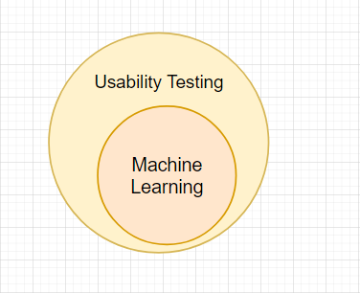

Figure 24 – Usability Testing & Machine Learning Subprojects

## 3.2 Software & Data Mining Methodologies

Due to the nature of the project two methodologies were used to manage this project. The first one is the Scrum Agile methodology and it is used to manage the more traditional software side of the project which is the web application and the local python application. The CRISP-DM methodology will be used to manage the data and machine side of the project that involves building a FER model. The CRISP-DM methodology is integrated into the Agile Scrum methodology and this will all be explained in this section of the report.

### Scrum Agile

One of the software methodologies that has been chosen for this project was the Scrum Agile methodology [69]. The Agile methodology is centered around iterative development and allows teams to deliver work with greater predictability which allows for better adaptability to change. The agile software development cycle is illustrated in Figure 25. In Scrum specifically, the development is split into development cycles called Sprints which are no more than four weeks. The project’s high-level requirements and goals are defined in the Product Backlog which is a dynamic list of Product Backlog Items (BPIs). This Product Backlog can change depending on the requirements as the project develops. These BPIs are used as input to the Sprint Backlog, which is a list of tasks, user stories, bug fixes etc. which need to be completed by the end of the sprint. At the end of each sprint the team reviews and evaluates the work. The Scrum methodology also has “Increments” which is the usable end-product from a Sprint [70].

Although this methodology is most commonly applied in a scenario with a team, the methodology itself provides a very useful process for managing a project with only a single individual. The product quality is improved as a result of breaking down the project requirements into manageable pieces and the focus is on the user with the project being able to adapt to the changing requirements. Prioritizing and reviewing the tasks increases the productivity of the developer as they can easily track the development and readjust if necessary [71].

ZenHub is an Agile project management tool that is natively integrated into GitHub and it will be used to manage the Sprints, BPIs, Epics and sprints etc. Figure 26 below illustrates what the management of Epics and Sprints looks like. All the requirements/issues are in the “Product Backlog” and gradually moved to the “Sprint Backlog” with each coming Sprint. Requirements that have been completed are moved to the “Done” section. Once they are reviewed and quality assessed they are officially finished and the issue is closed. Figure 27 shows the more detailed information of an Epic. For example, the Facial Expression Recognition Epic has 8 issues and 3 of them are already been completed.

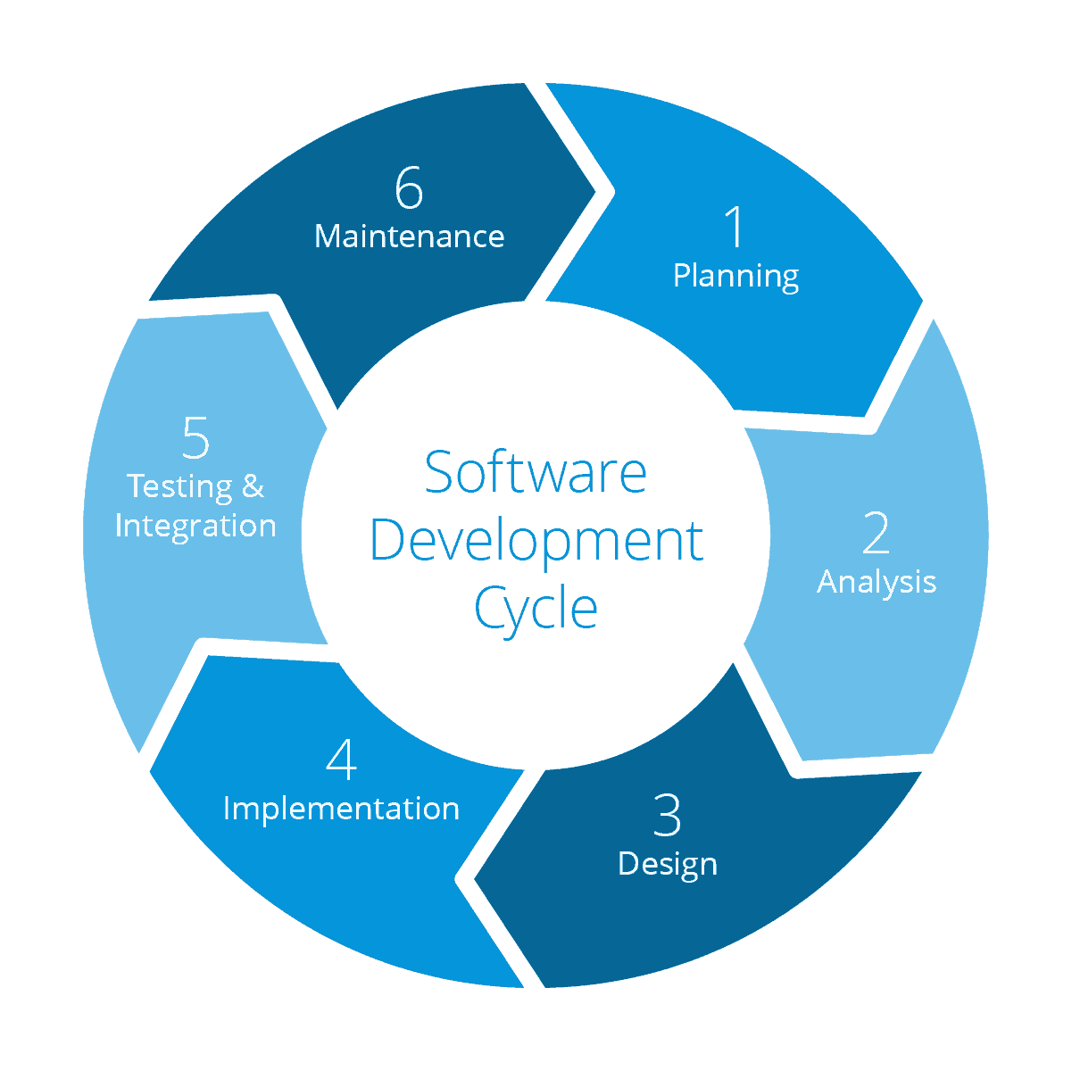

Figure 25 – Scrum Agile Software Development Cycle

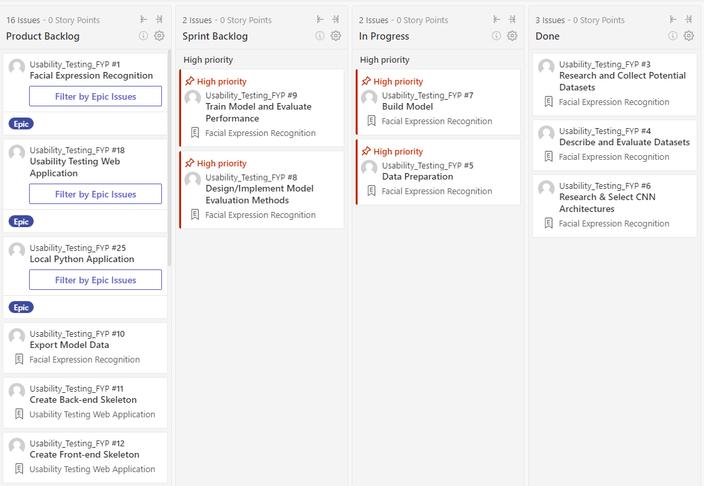

Figure 26 – ZenHub Epic and Sprint Planning (06/11/2020)

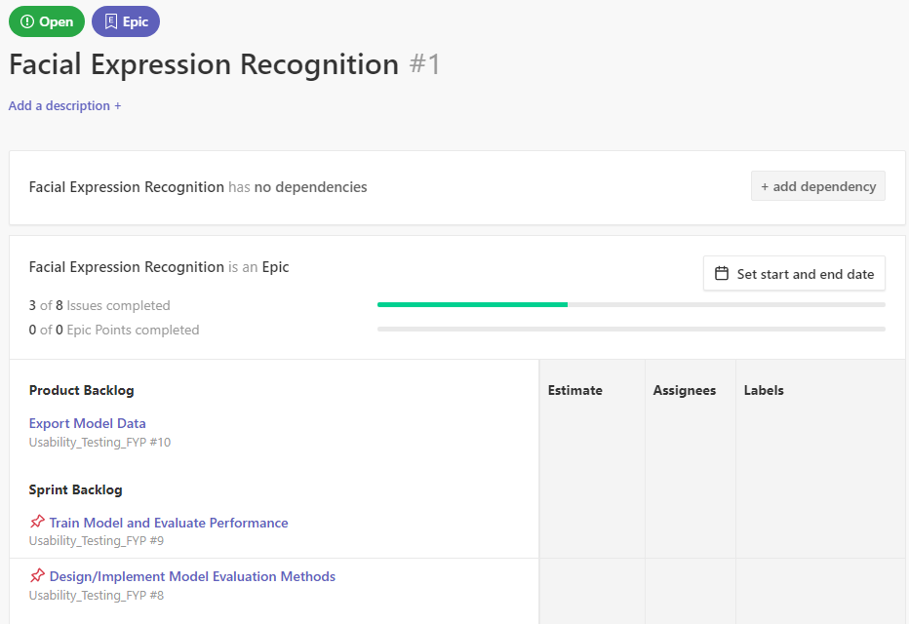

Figure 27 – ZenHub Facial Expression Recognition Epic

### CRISP-DM

The CRISP-DM (Cross-Industry Process for Data Mining) methodology was used in the design and development of the facial expression recognition model. This methodology, much like agile it focused on iterative progress. The cyclical iterative process consists of 6 stages which are illustrated in Figure 28 [72][73].

#### Stage 1: Business Understanding

The goal of this stage is to understand the business objectives and to reveal factors that could affect the outcome of the project. This involves looking at the resources, constraints, risks and requirements, and then forming a plan.

#### Stage 2: Data Understanding

This stage involves creating an initial data collection report that lists the data sources that have been acquired and where they have been obtained from. The second stage also involves the creation of a data description report that outlines the format, quantity and other relevant features of the data.

Stage 3: Data Preparation

This stage involves analysis, selecting, cleaning, constructing and combing the data.

#### Stage 4: Modelling

Involves selecting the modelling technique, generating a test design for how the model will be evaluated, building the model, and finally, assessing the model.

#### Stage 5: Evaluation

This stage involves reviewing the models and determining the future steps that will need to be taken to ensure the requirements are satisfied.

#### Stage 6: Deployment

The final stage is where a deployment plan, a monitoring plan, maintenance plan is created and the model is deployed.

This methodology is needed as data science is different in nature compared to software development in that significant time is spent on experimentation. CRISP-DM methodology is integrated into Scrum Agile by creating backlog items that are data science specific.

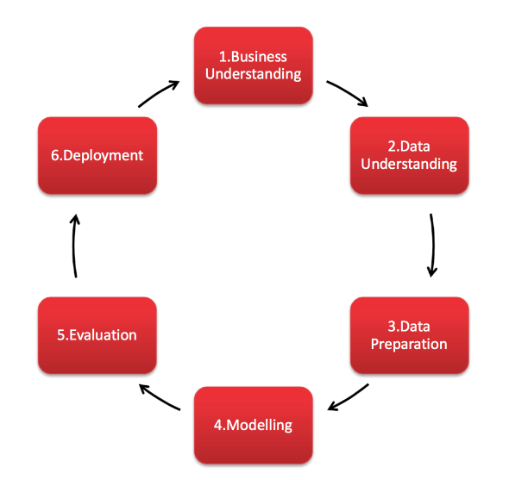

Figure 28 – CRISP-DM Methodology Cycle

## 3.3 Overview of System

The project is divided into two significant subprojects. These two subprojects are the facial expression recognition machine learning model and the usability testing applications. Each have their own set of requirements and can be thought of as separate projects that are later integrated. Figure 29 illustrates the high-level steps that are taken in each subproject, showing how each is will be developed. The machine learning subproject involves working with data and training a neural network. The usability subproject involves a web application to configure the usability tests and displaying the results/data. The local application runs the machine learning model and runs the usability test.

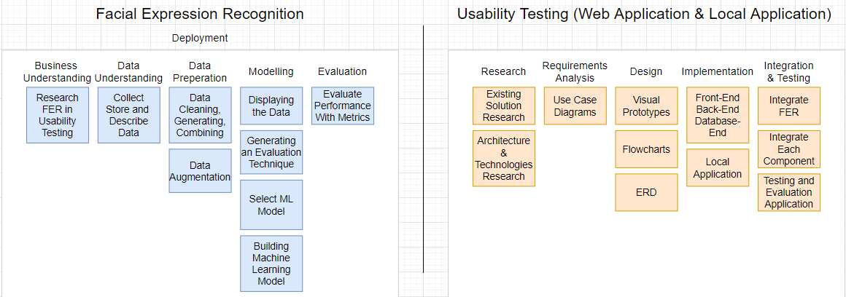

Figure 29 – Subprojects’ High-Level Steps

This project involves two applications. One application runs locally on the participants computer where the usability test will be conducted. Another application is the web application which has a front-end, back-end and database. There is another very important part to this project which is the facial expression recognition model.

Below is a very high-level view of the system that shows the data from the webcam being fed into the machine learning model that makes a prediction of the facial expression. The data is processed in the local application before it is uploaded to the web application where it is then stored and visualised for the researchers. Other data is also sent; however, the diagram is designed to specifically show how the machine learning aspects fits into the system.

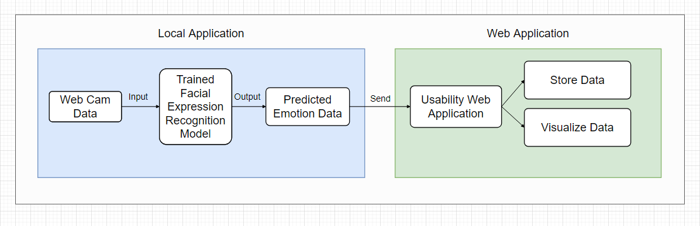

Figure 30 – High Level View of System

A more in-depth view of the architecture of the web application and the local Python application is shown in Figure 31. The web application is a 3-tier architecture with a client, server and database. The front-end of the web application will be programmed in JavaScript and the ReactJS library is going to be used to aid development. The other option researched was the Angular Framework for JavaScript and both Angular and React are great options for front-end web development. Neither of the two have been worked with before and React was chosen as it is said to have an easier learning curve and is the more popular option with a bigger community. From another point of view the UI tools are developed by the community and there is a wide range of options of libraries that provide charting UI which is very necessary to display the data in this project.

The back-end of the website will be programmed in Java with the Spring framework, managed with Apache Maven and hosted on an Apache Tomcat server. The research has concluded that this is one of the best and most popular options for setting up a back-end for a web application in Java. The reason Java was chosen over Python and Django is that some sources claim that Django has a steep learning curve and it would not be wise to attempt learn an entirely new framework given the time constraints. It would simply be an unnecessary risk to the project given that there is familiarly with a perfectly suitable solution in Java. As this solution is also familiar it will lead to less mistakes in development. For the database tier MySQL was chosen.

The local python application connects to the back-end via the REST API and the same goes for the front-end of the web application. The data is processed in the service tier and passed to or received from the DAO classes that connect to the database. The FER predictions by the model are made locally on the participants computer as this is where the usability test will be ran.

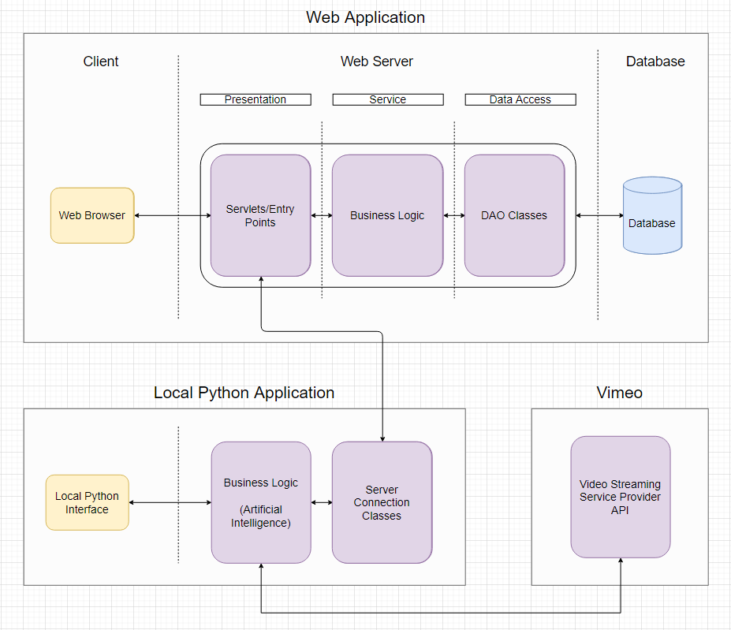

Figure 31 – Architecture of Applications

The high level operations of the system which includes the creation of a usability test and the usability test being conducted with a participant are illustrated in Figure 32. This diagram does not go into low level detail when it is not necessary and is mainly used to show how the components fit together and how the program flows to help increase the understanding of the system. This diagram also does not show the researcher viewing the results of the usability test as this will be explained in detail with the help of screen prototypes of the user interface.

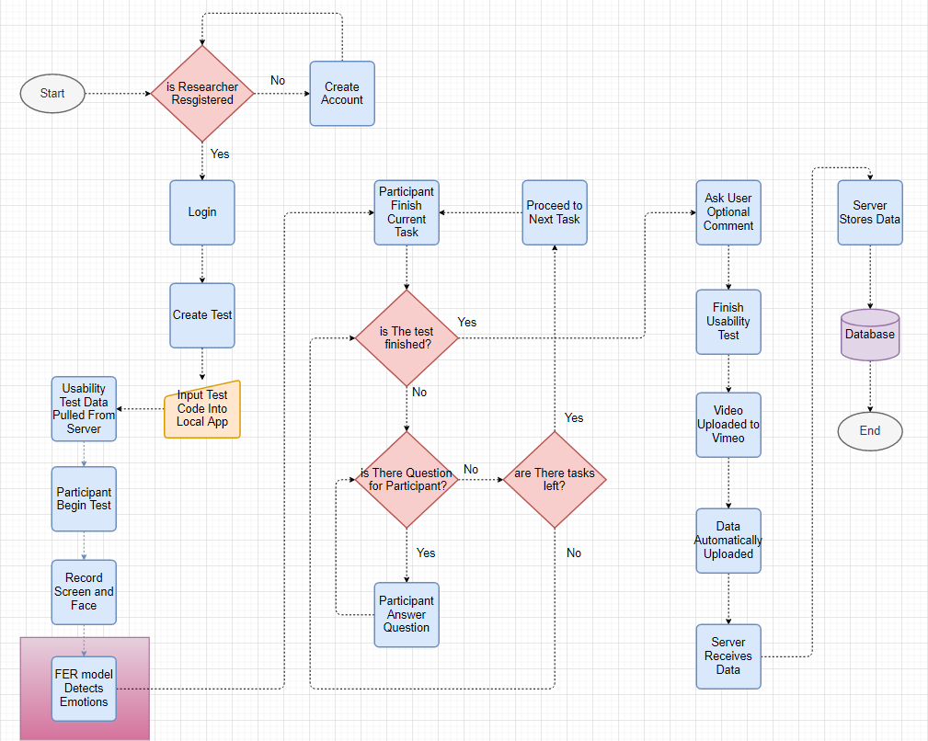 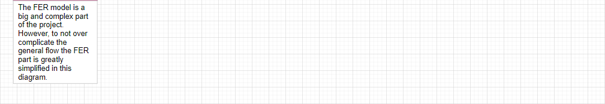

Figure 32 – High Level Flowchart of System

## 3.4. Web Application

### 3.4.1 Front-End

#### Use Case Diagrams

The first iteration of the developer/researcher (“developer” and” researcher” are used interchangeably as it could be either or both) use case diagram is illustrated below in Figure 33. There is register and login functionality so that each researcher has their own separate account. The researcher can create usability tests which include creating tasks and questionnaires for the participant to complete. After the usability test is conducted the researcher can view the average success and failure rate of the tasks within the tests. To explain what is meant by the average success rate the following example will be used. A test is conducted twice, the test has 5 tasks, the 1st participants failed one task and the 2nd participant failed two tasks then the success rate would be 7/10 as three tasks were failed amongst the two participants out of a total of 10 tasks.

The researcher can also watch the video of the screen recording and the camera recording. The researcher can view what emotions the participant showed on a timeline.

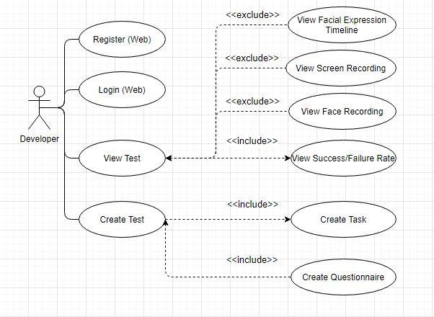

Figure 33 – Researcher Setting Up Usability Test Use Case

The next iteration of the researcher use case diagram is displayed below in Figure 34. Additional features were added to the the use case. On top of the task creation and the questionnaire creation there are more options such as a multiple choice question which can come in the form of an open-ended multiple choice question and a rating question. Questions may be asked before or after the test and a scenario can be created for user before they begin the test. The starting URL can be set with Selenium so that the user does not have to copy and paste the link into the browser manually. When it comes to viewing the test results, the metrics and charts to be displayed are more defined in this use case diagram. The use case is also more specific on how the emotion data will be displayed i.e. with a journey map, which was been discussed in section 2.1.1.

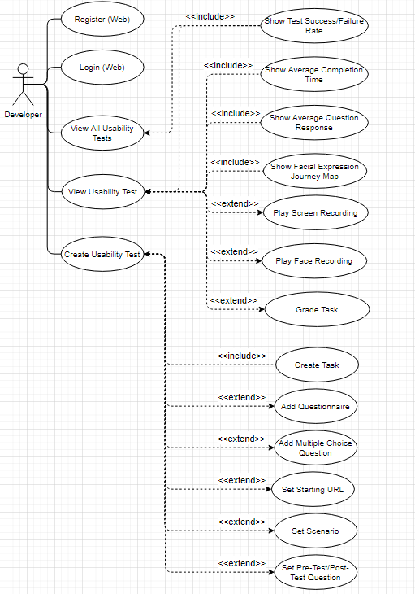

Figure 34 – Researcher Setting Up Usability Test Use Case (Second Iteration)

The use case diagram for the participant who is going to be using the local python application is illustrated below in Figure 35. First the test details are obtained from the web server. Using this data the local application will execute the correct instructions at the right time such as displaynig the tasks and asking the participant questions etc. The test will begin and the user can minimize/maximize the instructions window that will be on the screen at all times. Once they are finished with the task they will press a button on the instruction window to proceed to the next task. The user will have to answer all the questions they are asked and will have the option to write an optional comment if they would like to add anything after the test is finished. Once the test is finished the data is uploaded automatically to the web server.

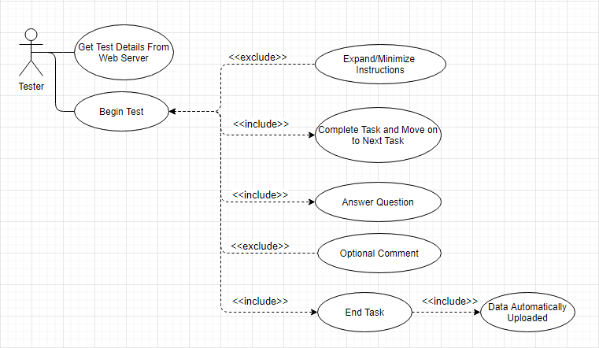

Figure 35 – Participant Use Case Diagram

#### Screen Prototypes

The “Dashboard” of the web application is the main screen the researcher will see after login and is illustrated below in Figure 36. The prototypes are designed with JustinMind. This is where the researcher can create new projects. This would relate to the “View All Usability Tests” use case. A “New Project” can be created for a new application to be tested and each project will have multiple usability tests. These usability tests can test various functionality of the program. In the example below we can see the status of the usability test (Open), the date the test was created (01/01/2020), the number of participants (5), the number of tasks passed (80%) and the number of tasks failed (20%).

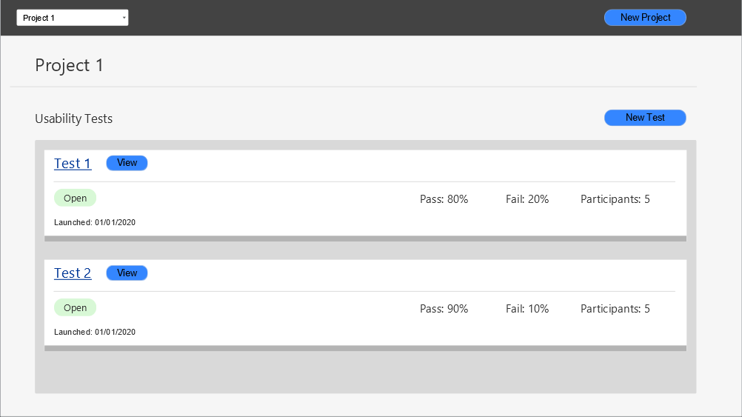

Figure 36 – Web Application Dashboard

The usability test creation screen which corresponds to the “Create Usability Test” use case is illustrated below in Figure 37. The researcher will name their test and insert questions or tasks. The question can be answered in plain text. There is a multiple choice question where the user is asked to pick one answer. There is a multiple choice questons with multiple answer.

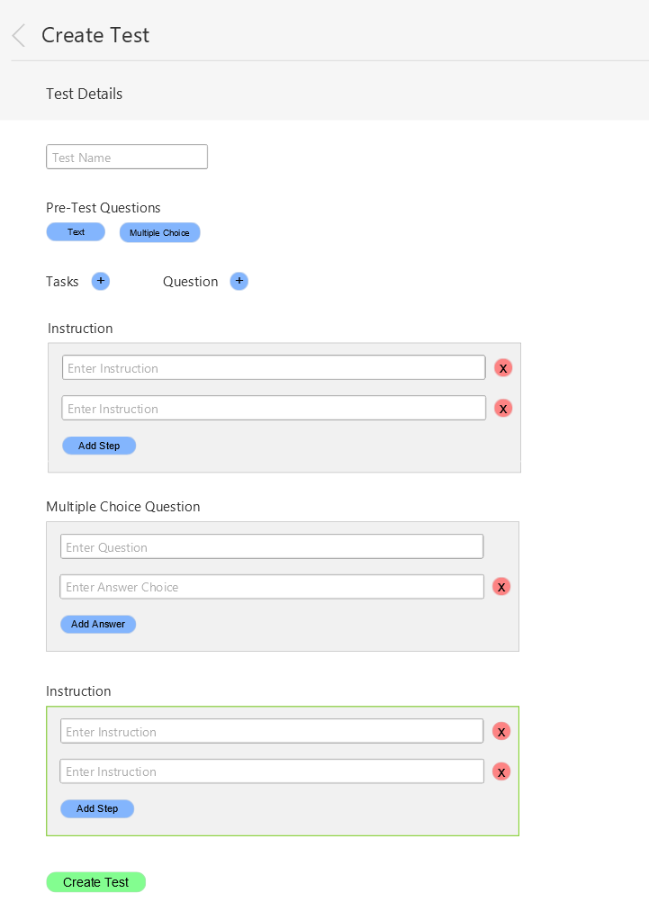

Figure 37 – Web Application Usability Test Create

The test results screen that the research is going to is illustrated below in Figure 38. This is the “View Usability Test” use case. The usability test name in this case is “Test 1” and this test has multiple tasks which include “Task 1”. The total success and failure rate across all the tasks is given in the overview. Below that the researcher can choose to view the data on an individual task. The first chart on the top left shows the success and failure rate. The chart on the right shows the emotions of all the participants during that task. This chart excludes the “Neutral” emotion as it does not provide any information. The frequency of the other facial expressions is obtained and plotted on the bar chart. The idea is that a face expression that occur for any length of time below 1 second are assigned a value of 1. If the face expression persists for longer than one second then the value will be incremented every other half second. In other words, if a face expression persists for 2 seconds it will be worth 3 points. This type of point system is used to capture facial expressions that persis on the partipants face for an extended period of time and more significance is assigned these facial expressions. This timing will have to be experimented with to gain an optimal result.

Another type of chart displayed is a pie chart and these can be used to display the answers to questions by all the participants. A possible question that a researcher might want to ask could be how difficult the participant found the task the rating could be from 1 to 5.

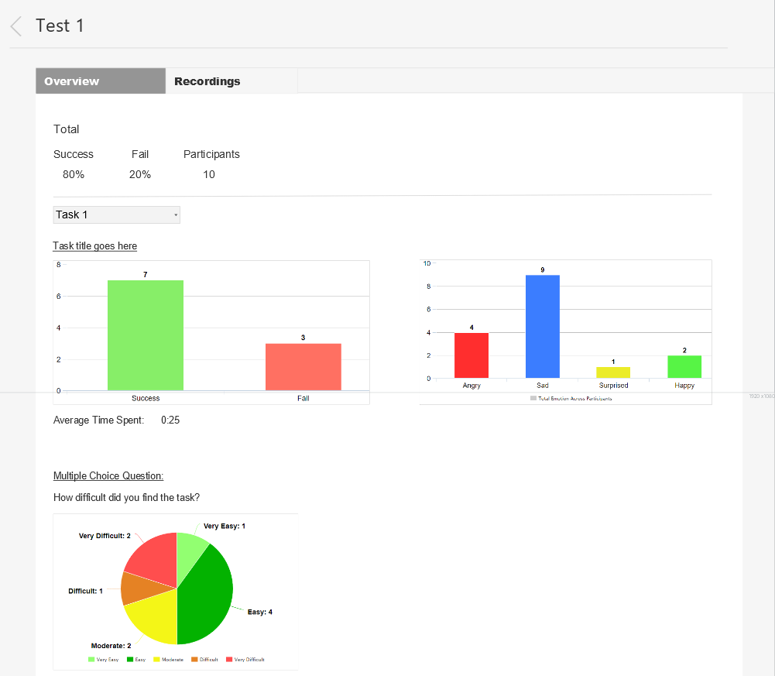

Figure 38 – Web Application View Usability Test Results

The page where the researcher can view the recordings and grade the usability test is illustrated below in Figure 39. The tasks will be graded with either a “Pass” or a “Fail” depending on whether or not the user has successfully completed the task. The video will be of the user’s screen as they complete the questions and tasks and will include the user’s camera feed. This will allow the research to not only see what the user is doing but also their face expression. The emotions are displayed in their respective colour below the video. The video markers are going to be implemented with Videojs-markers [74]. This will help the researcher(s) find the points of interest in the video faster and this will also show them an overview of the video in terms of the emotions. Below the video is the first implementation of the journey map. The chart was evaluated by Andrea Curley, the project supervisor, and one of the possible issues identified was the visual effect the length of the bars might have. The length of the bars are simply the result of the vertical structuring of the emotions with “Happy” being at the top and “Angry” being at the bottom. The length of the bars seem to add unnecessary depth and as a result makes the data the chart is displaying less clear.

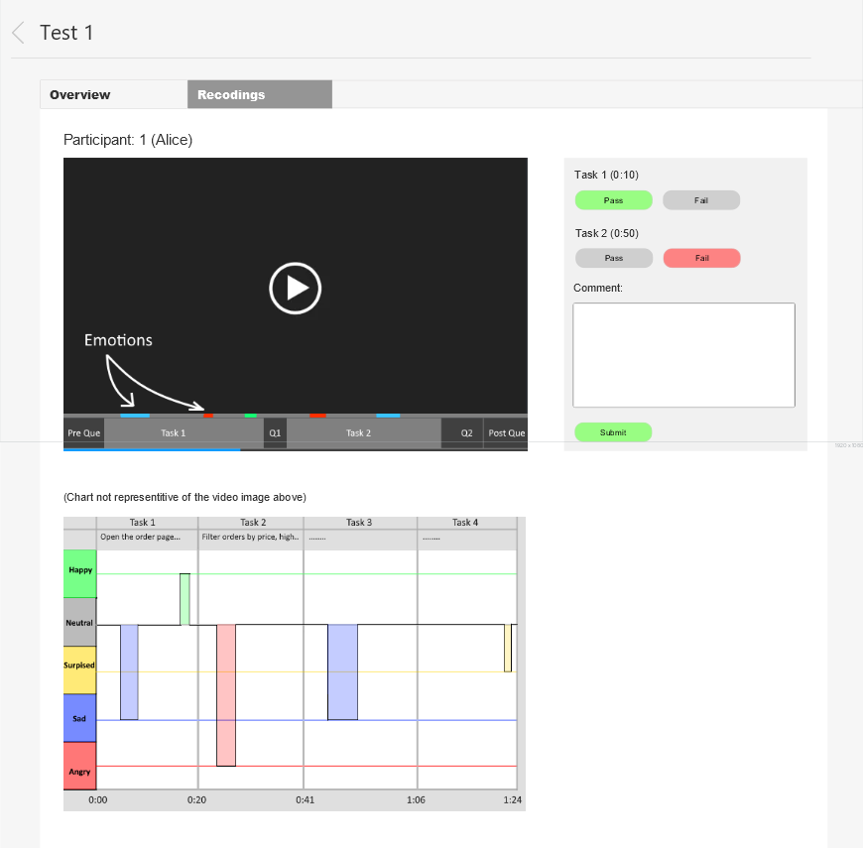

Figure 39 – Web Application View Recordings

The second design of the journey map after the evaluation is illustrated in Figure 40. In this version the emotions are split into positive and negative with each bar now being the same length. “Surprise” is labelled as a negative emotion because usable functionality should not be surprising to the user. If the participant is surprised by anything this should not be brushed off as a positive thing and should be investigated.

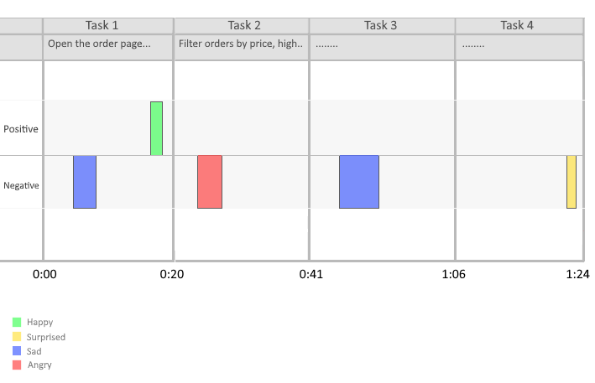

Figure 40 – Journey Map v2

### 3.4.2 Back-End

### 3.4.3 Database

For the database tier, the RDBMS chosen was MySQL. The reason for this choice over Firestore was because the data follows a hierarchical structure and it makes more sense to use a relation database as opposed to a non-relation database like MongoDB and Firestore.

Figure 3.4.3.1 illustrates the design of the database. Each researcher can have many projects, and these projects can have many tests. Each test must have tasks and may have questions. In the first iteration the ParticipantTest table referred to an instance of usability test. In other words, this table is used to store information about a completed usability test. The name “ParticipantTest” did not make complete sense and this was changed to “TestInstance” in the next iteration.

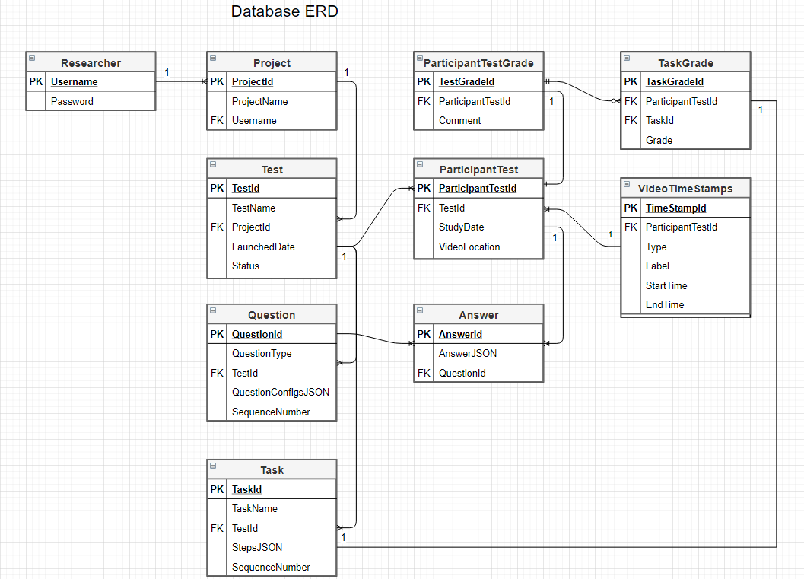

Figure 41 – Web Application ERD

## 3.5 Local App

The local python application that will run on the participants machine is illustrated in Figure 42. The participant or the researcher (if they are in the same room) will enter the test code into the dedicated text box and click “Submit”. The details for the usability test will be pulled from the web server back-end and displayed on screen. That was the “Get Details from Web Server” use case. Once the details are verified as correct the participant will enter their name and click “Begin” to begin the text.

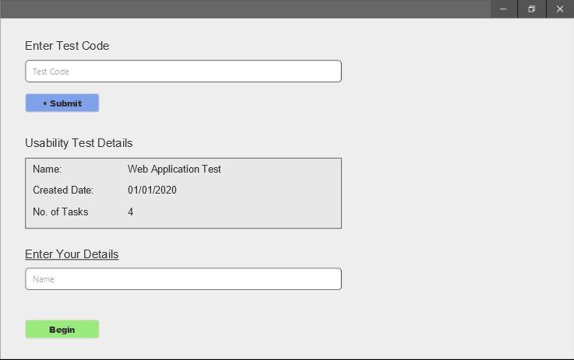

Figure 42 – Local App First Screen

Once the test begins the participant will see a similar screen to what is illustrated in Figure 43. In the top right corner are the instructions for the task that the participant needs to complete. Around the edge of the screen is a red border. This is to visually indicate that the session is being recorded. At the bottom center is a small box that says “Recording” to definitely let the participant know they are being recorded. They may press the “Stop” button to stop the test prematurely. Once the participant is finished with their task they are to click the “Finish Task” button to proceed to the next task.

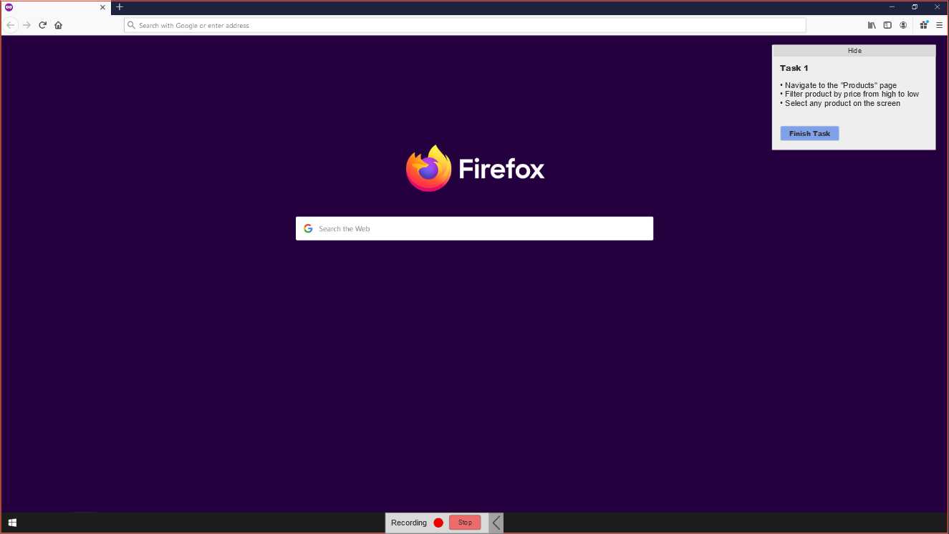

Figure 43 – Local App Usability Test Started

## 3.5. Facial Expression Recognition & Machine Learning

### CRISP-DM Methodology in Prototype Development

This section will discuss the design decisions made with regards to facial expression recognition and machine learning. Following the CRISP-DM methodology the first stage is “Business Understanding”. This involved research into the field and the questions such as “How to present the emotion data?”, “What emotions are necessary in the field of usability testing?”. In the research paper by Landowska (2015) [[6]](https://www.researchgate.net/publication/301454217_Towards_Emotion_Acquisition_in_IT_Usability_Evaluation_Context) there was mention of combining the basic emotions to create more complex emotions. The risk associated with combining emotions is the prerequisite that it has been correctly detected and secondly that it will be interpreted correctly by the researcher. Emotions such as empowerment might make more sense than simply “Happiness”, however, it can be misleading and more difficult to detect as the participant could simply find some part of the system amusing. Boredom is an emotion that consists of “sadness”. Once again, this can be misleading as someone frowning could mean much more than boredom. Hence a decision was made to simply display the basic emotions.

The second stage of the CRISP-DM methodology is “Data Understanding”. The data has been collected, stored and described. Practically every dataset researched was different in some way and the data format especially needs to be made consistent so that the input into the machine learning model is the same. In the research section the reasons for why certain datasets were not chosen for training the model were already discussed. In the research section the datasets were also described and discussed in detail.

The third stage is “Data Preparation” and involves analysing, cleaning, constructing and combing the data. The FER2013 dataset is in the form of a .CSV file with a column dedicated to the pixel values of the grayscale image. The other datasets that are planned to be used are the JAFFE and FacesDB datasets, both of which are in the form of .tiff and .tif images respectively. A decision was made to convert the pixel values in the FER2013 dataset to actual images that can be stored on the computer. This will be accomplished with the help of the NumPy, Pandas, and OpenCV libraries. The other option was to simply write a method for taking the data out of the CSV file but not storing it and instead feeding it directly into the machine learning algorithm for training. However, for the sake of consistency this was not the route taken. There will be three directories, “Training”, “Validation” and “Testing”. The folders within each of the directories will follow the same structure with a folder for each emotion and this is illustrated in Figure 3.5.1. The both Keras and Scikit-learn Python libraries can be used to shuffle and split the data if testing and validation images have not been provided. This is the case with the JAFFE and FacesDB datasets.

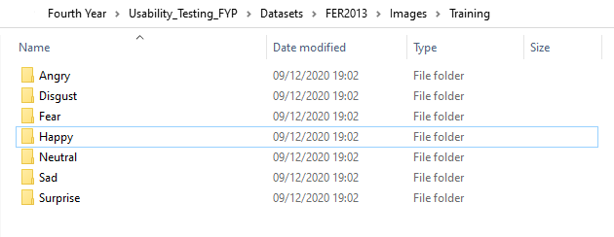

Figure 44 – Dataset Folder Structure (Training)

As mentioned in the research section data augmentation techniques will be used to generate more data from the existing dataset. This can be accomplished with the Keras ImageDataGenerator function which will rescale, rotate, sheer, zoom, shift and flip the image horizontally.

The fourth stage is “Modelling” and involves selecting the modelling technique, generating a test design for how the model will be evaluated, building the model, and finally, assessing the model. There is quite a lot involved in this stage and the focus in this section of the report will be where ever the prototype aspect is applicable. The charts for modelling the data (e.g. Journey map) have already been discussed so the focus will be on the evaluation techniques for the model and as discussed in the research section the metrics used will be the confusion matrix, accuracy, recall and precision. The intended loss function that will be used is Categorical Cross-Entropy loss (also known as SoftMax Loss). It is a SoftMax activation plus a Cross-Entropy loss. The CNN architecture of choice is the VGG-16 architecture. The next two stages in the CRISP-DM methodology are evaluation and deployment. Both of these stages will be discussed in a later sections of the report.

### Discussion

As mentioned previously the data from the camera will be fed into the FER model. The output data at the very end will be a dictionary of timestamps (HH:MM:SS:MS) with alternating facial expressions. For example, the sample output will look like:

{

“00:00:00:00”: “Neutral”,

“00:00:05:00”: “Happy”,

“00:00:06:10”: “Neutral”,

}

In the presence of no emotion in the scenario that the model did not detect anything the “None” value will be stored. The timestamp will be to a tenth of a second in accuracy to ensure the facial expressions are accurate.

## 3.6 Conclusions

The stages of the project and the tasks that need to be completed (development) are broken up into 3 stages and illustrated below in Figure 45.

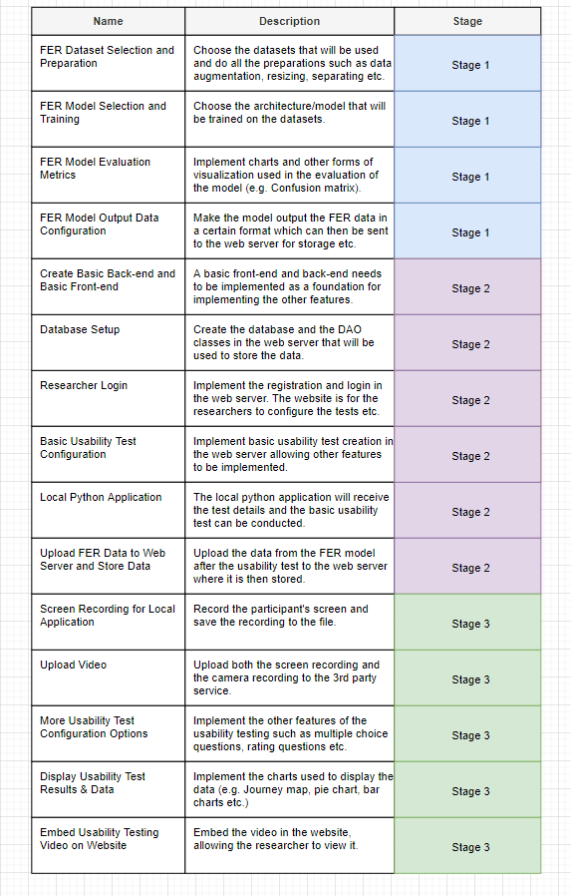

Figure 45 – Project Tasks & Requirements

# **4. Prototype Development**

## 4.1. Introduction

This section will cover the machine learning development and software used in the development process. To backup and manage this project a GitHub repository was created. Git is a version control tracking system and tracks changes of files. Eclipse IDE for Enterprise Java Developers is used for creating the web application’s backend and Visual Studio Code is used for the frontend development with JavaScript. The FER model and other machine learning related functionality will be created in Jupyter Notebook in Anaconda. With Anaconda an environment is created which is a directory where all the packages are stored. This includes Python packages and these packages, even if present on the machine need to be installed in the environment. This is useful as it allows the developer to have multiple versions of Python or Python libraries on the same machine. Jupyter Notebook a very useful development tool that serves as not only an IDE but also a presentation tool where images can be displayed. This makes it very suitable for data science and machine learning.

## 4.2 Machine Learning

### 4.2.1 CSV to Image Converter (CRISP Data Preparation Stage)

Figure 4.2.1.1 illustrates the FER2013 dataset in its original format, a CSV file. The *pixels* column consists of 2304 (48 x 48) pixel values which are converted into an image. Figure 4.2.1.2 illustrates a sample image post conversion. Each image has a label which corresponds to one of the 7 emotions (Angry, Disgust, Fear, Happy, Sad, Surprise, Neutral) with a value ranging from 0 to 6.

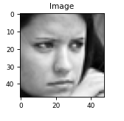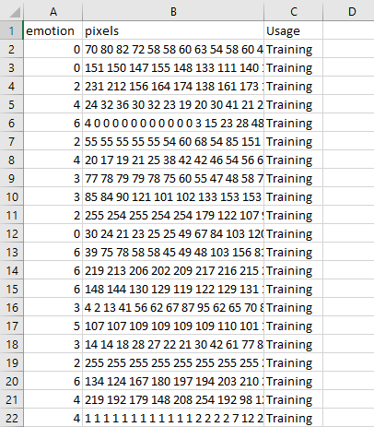

Figure 46 – FER2013 Pixel Values as Image

Figure 47 – FER2013 Dataset CSV File

Below is the code for opening the CSV file, obtaining the relevant information and saving the image as a .jpg file. A dictionary is created that contains the label number and the label name. This dictionary is used to ensure that the image is stored in the correct folder.

The libraries such as Pandas, NumPy, OpenCV and Matplotlib are imported as these will be used in this script (See Figure 4.2.1).

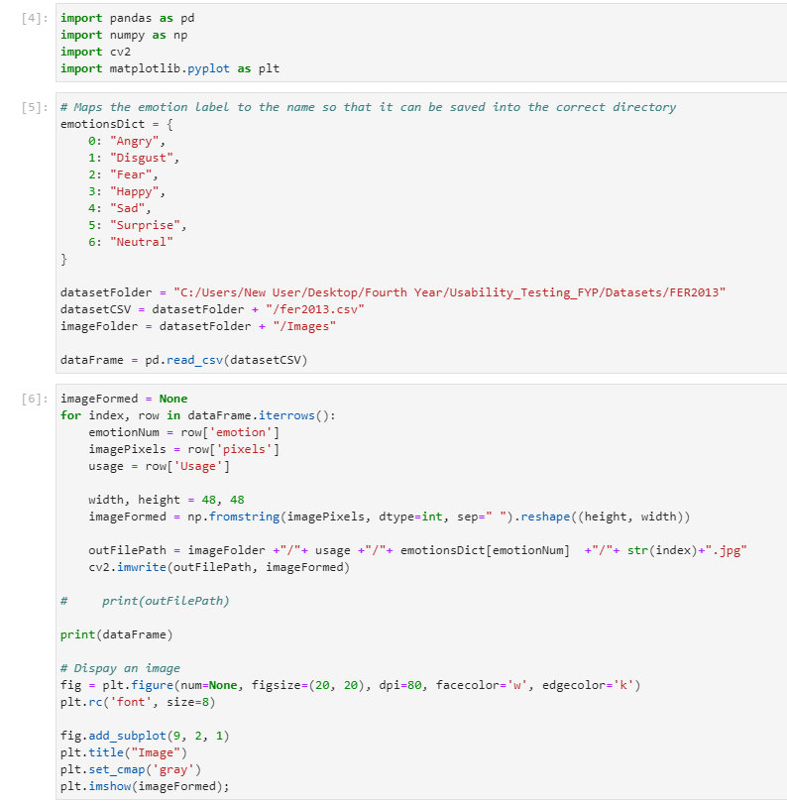

Figure 48 – Imports

A dictionary is created to map the label number to the corresponding name. The path variables are initialized and the CSV file is opened/read with Pandas (See Figure 4.2.2).



Figure 49 – Path Variables and Opening File

Each row in the CSV file is iterated over and the values in each column is extracted. The pixel values are then stored in a 48x48 matrix and this matrix is saved as an image to the correct folder (See Figure 4.2.3).



Figure 50 - CSV to Image Converting and Exporting

The final end results is images in their respective folders as shown below. All the images labelled “Happy” are in the “Happy Folder”.

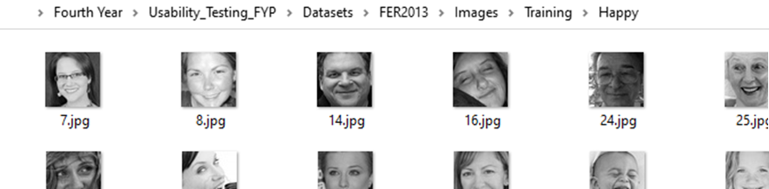

Figure 51 – Converted Images

### 4.2.2 Model Training (CRISP Modelling Stage)

#### Model 1

The first attempt at training a CNN began with training a modified VGG16 architecture from a GitHub repository found online. The dataset used was FER2013 with a total of 35,866 images split into training, validation and testing in the ratio of 80:10:10. The validation accuracy on the FER2013 dataset was an acceptable 57.7% with the state of the art for a VGG model for that dataset being 72.4%. The model was trained for 25 epochs. However, the confusion matrix for this model would not display properly. Unable to find the root case and unsure if the issue was with the model or input to the confusion matrix another model was used to get more information that could help with the problem. Later in the evaluation data from the camera was fed to the model and successfully predicted the emotion given the accuracy indicating that the problem lies in the input to the confusion matrix.

#### Model 2

In the second model the CNN architecture was different (See Figure 4.2.2.1) and unlike the other model it did not involve data augmentation/generation. The dataset used and the ratio split is the same as with the previous model. The model has achieved a 56% validation accuracy after 30 epochs which is less accurate than the other model by a significant amount. However, this time the confusion matrix successfully displayed the data. This was confirmed by manually adding up the values and obtaining the accuracy from the matrix and comparing it with the expected accuracy.

The architecture of the model below is similar to the VGG architecture and was mainly used for experimentation purposes. The Architecture diagram is illustrated in Figure 4.2.2.1.

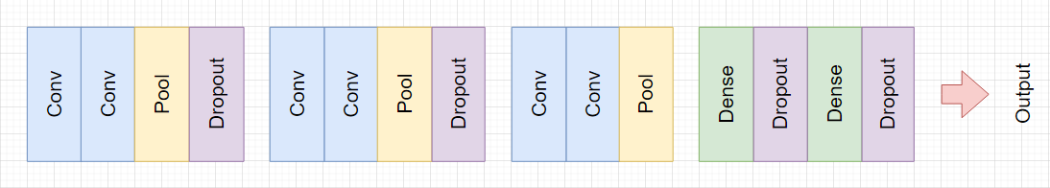

Figure 52 Second Model Architecture

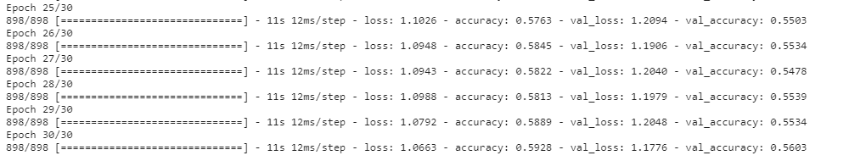

Figure 53 – Second Model Training

To explain the code, first the paths to the train, validation and testing data is initialized. The training date will be used in the training of the model, the validation data will be used to check how the model performs on unseen data and finally the testing data, much like the validation data will be used to see how the model performs on another set of unseen data.



Figure 54 – Path Declaration

The dataset images are read from the folders and stored in their respective arrays (X_train, X_valid). Another array is for the labels (train_y, valid_y) and the index in the arrays is used to map the image to the label.

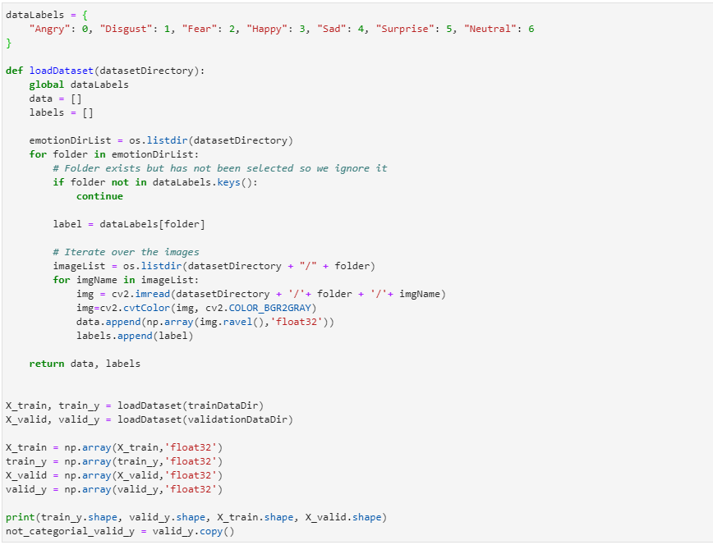

Figure 55 – Loading Dataset from File

An arbtrary number of features and batch size is selected. The number of labels corresponds to the number of facial expressions and the number of epochs. It has been observed that past 25 epochs the accuracy on the validation dataset does not increase by much if at all.

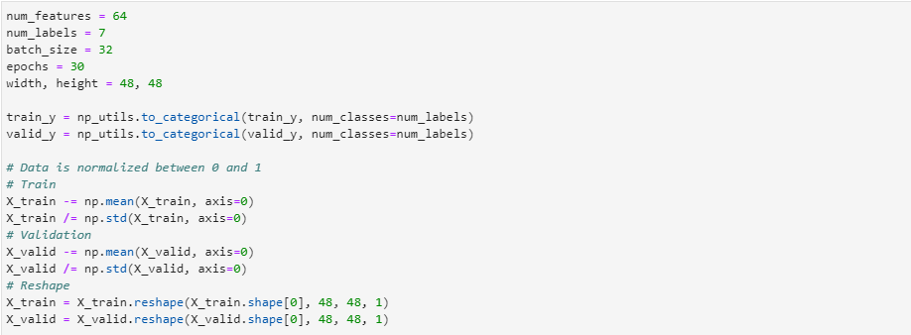

Figure 56 – Configurable Variables and Data Normalization

The code for the architecture illustrated in Figure 52 is displayed below in Figure 57.

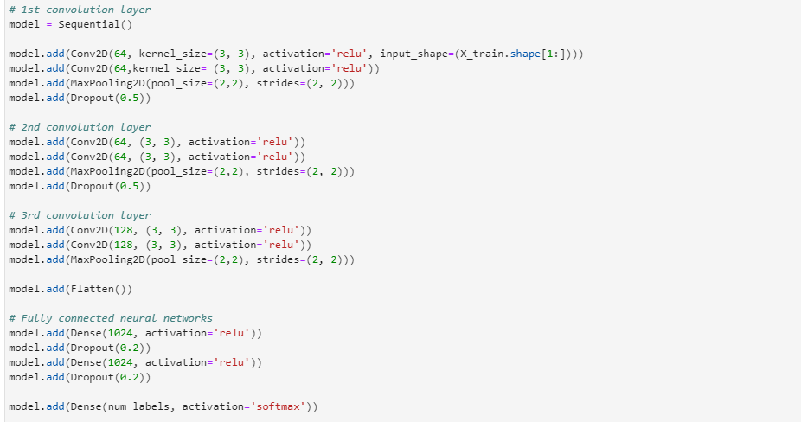

Figure 57 – CNN Architecture Code

### 4.2.3 Model Evaluation & Discussion (CRISP Evaluation Stage)

#### Model 1

The model has been trained to recognise 7 different emotions, just as the second model. Below Figure 58 illustrates the accuracy increase in the last few epochs with the final accuracy on the validation set of 57%. The accuracy increase and loss decrease is illustrated in Figure 59. Oddly the validation set accuracy was always higher than the training set accuracy. After further research this could be caused by the Dropout layer when training. Another possibility is the training and validation ratio.

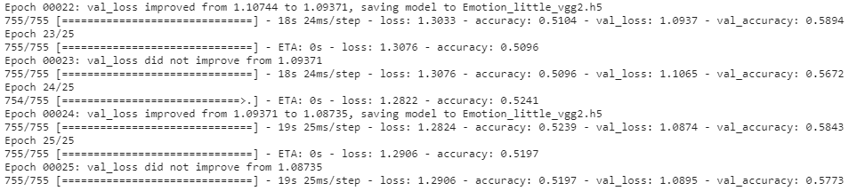

Figure 58 – First Model Training

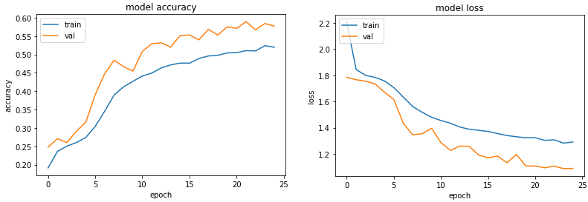

Figure 59 – First Model Accuracy and Loss

The model is finally put to practice in a real-world testing environment. This is illustrated in Figure 60. The emotions of fear and disgust were very difficult to detect and would most of the time fall under the “Sad” or “Angry” category. Generally, the model has performed very well in detecting the 5 basic emotions below. The “Happy” facial expression is illustrated twice to highlight that both an open mouth smile and a subtle smile are both captured. This is important as in a usability testing environment the facial expressions are expected to be subtle at times. The camera location has also been experimented with and the camera position at the top of the screen has yielded the best results. In the research paper by Landowska (2015) the camera was at the bottom of the screen which did not prove as effective.

To detect the face Haar Cascade classifier was used. The face detected is shown with a blue bounding box. The face is then extracted and processed before being fed to the model for emotion classification.

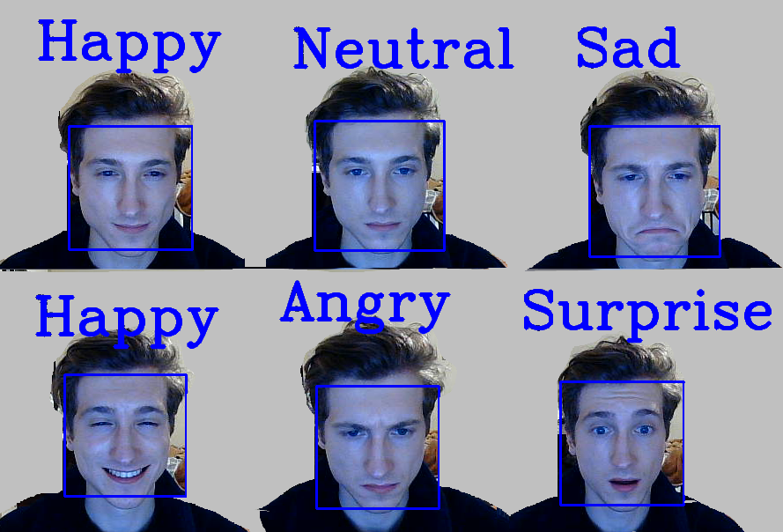

Figure 60 – First Model Camera Feed Predictions

#### Model 2

The second model, as mentioned before has achieved an accuracy of 56%. The model’s precision in detecting a happy facial expression is 76% with a recall of 79% which is much higher than the other emotions. The precision of “Disgust” is 73%, however the recall was at a lowest 24% and the sample size was much smaller than the other emotions. The model could be possibly be improved by removing the “Fear” facial expression as it is not exactly applicable in the usability testing scenario and only increases the complexity. The “Disgust” emotions is incorrectly predicted as angry and sad in a lot of cases. From the matrix we can also see that the model has predicted sad when the true label was natural and vice versa.

The data from the camera was fed to the model as previously done with Model 1. The predictions appeared to be not very accurate at all and could definitely not be used in a production environment. This was because the emotion “Happy” was detected even when the face was neutral, sad, angry etc. The model has an extreme bias towards this facial expression. In conclusion, although the accuracy of the second is somewhat low it provides some insight into how emotions are predicted by looking at the confusion matrix and seeing which types of emotions are likely to overlap. This experiment also serves as a foundation for evaluating the future models.

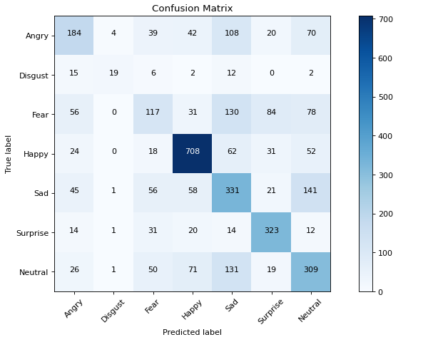

Figure 61 – Confusion Matrix of Second Model

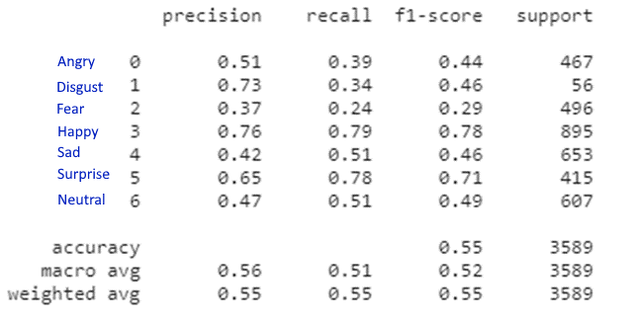

Figure 62 – Metrics for the Second Model

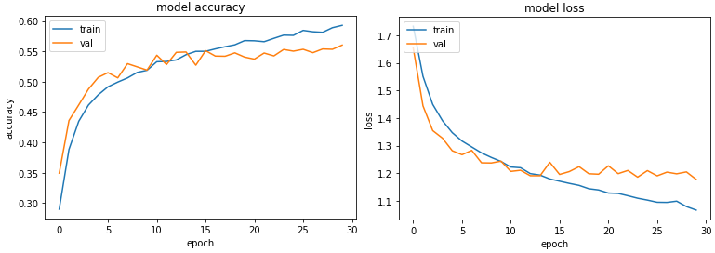

Figure 63 – Accuracy and Loss Charts for the Second Model

## 4.6. Conclusions

In conclusion two models were trained and evaluated. The first model is more complex and predicts with relatively high accuracy on both the validation data and the real-world camera feed data. However due to technical issues the confusion matrix and other in-depth metrics could not be displayed. The second model was implemented differently and detected the facial expression with a lower accuracy. However, with the second model the displaying of the confusion matrix and other metrics was successful which allowed for more in-depth evaluation. The plan going forward is to display the metrics for the first model and train the model on the JAFFE and FacesDB datasets. Data augmentation techniques can be employed in the second model to try and increase the accuracy.

# **5. Testing and Evaluation**

## 5.1. Introduction

This project will be continuously tested throughout the development cycle. The CRISP and Agile methodologies are being followed and both have testing in their cycle. With Agile testing will occurs at each sprint and the implemented functionality for that sprint will be tested. Each unit will be tested to ensure it is working as intended and provides the required functionality. In the CRISP-DM methodology evaluation is one of the stages and it involves evaluating the model with the designed testing plan. Throughout the development of the project changes are consistently committed to GitHub to ensure that changes can be rolled back to the previous working version in the scenario that major errors occur.

Black-box testing involves testing the functionality/system with no prior knowledge of the internal workings of the system which includes the design/architecture etc. This testing can be done via the user interface and a user provides some type of input whether it be a mouse click or keypresses and then observes the output of the system. This type of testing can be used to find bugs and errors in the user interface, error handling and functionality errors etc [75].

White-box testing involves looking at the internal structure of the system and more specifically at the code. The person looking at the code has prior knowledge of the system. White-box testing can be automated with methods and classes that input many possible input types into the unit in an attempt to discover errors and ensure that the correct input gives the correct output. Automated testing is very useful as the system changes and new functionality can break existing functionality that worked previously. It saves the developer/testers from having to manually check to make sure that the functionality is still working which is time consuming [76].

Grey-box testing can be thought of as a combination of white-box testing and black-box testing as the tester has at least some prior knowledge of the internal working of the system. The tester does not necessarily have access to the code, however with the knowledge they possess they are able to conduct more complex tests [77].

The following sections will discuss the plan for unit testing, integration testing, system evaluation. The machine learning and facial expression recognition specific evaluation will also be discussed.

## 5.2. Plan for Testing

### 5.2.1 Unit Testing

Unit testing will be used to test the functionality of each component that is part of the system. Unit tests can be black box or white box. Black-box testing is done using the user interface and white-box testing involves testing the internal workings of a unit. These will help find the bugs in the system and ensure that the functionality is working.

|  |  |  |
| --- | --- | --- |
| Test Description | Expected Outcome | Pass/Fail |
| Researcher register | User will be redirected to login screen and a pop up will notify them that the register was successful |  |
| Researcher login with correct details | User will be redirected to main screen (Dashboard) |  |
| Researcher logout | User will be redirected to login screen |  |
| New project button is pressed | A pop-up form will appear on screen with input fields |  |
| New test button is pressed | The “Create Test” page will open |  |
| Add instruction in create test | A box will appear on screen with an “Enter Instruction” field that needs to be filled out |  |
| Add step to instruction | Another text field will appear in the instruction box |  |
| Add text question in create test | A box will appear on screen with a “Enter Question” field |  |
| Add multiple choice question in create test | A box will appear on screen with a “Enter Question” and “Enter Answer Choice” field |  |
| Add/Remove instruction step | The additional instruction steps that have been previously added will be removed |  |
| Create Usability Test | The researcher clicks on “Create Test” button and the new test is stored in the database |  |
| Click “View” test button in dashboard | The user will be redirected to the “View Test” screen |  |
| Bar chart displaying data | The proportions of the chart are correct and correspond to the values |  |
| Pie Chart displaying data | The proportions of the chart are correct and correspond to the values |  |
| Task select in “Overview” | A drop-down menu will pop up with the tasks that can be selected by user |  |
| Play video | Video will play |  |
| Grading tasks | Clicking “Pass” or “Fail” will change the colour of the button to green or red respectively |  |
| Display journey map | Journey map displays correctly and reflects the data |  |
| Screen is recording | A red border will contour the border of the screen the screen will be captured |  |
| Screen recording can be stopped | User clicks on “Stop” button and the recording will cease |  |
| Move on to next task | The user clicks on the “Finish Task” button and moves on to the next stage of the usability test. |  |
| Video saved locally | The video will be saved to a local directory under the correct name |  |
| Video upload to Vimeo | A link is returned by the Vimeo API and can be played |  |
| Task instruction is displaying to participant | Task instructions for the participant display on screen |  |
| SQL injection working | Data is correctly stored in the database using the SQL query. Data retrieved from database with SQL query. |  |
| Web server REST Entry points working | Data can be passed to or retrieved from the web server via POST and GET requests. |  |
| Facial expressions detected correctly with real users | The user will make various facial expressions in front of the camera and the prediction will display on screen. |  |

### 5.2.2 Integration Testing

Integration testing involves connecting the units/components and testing them as a group. This type of testing is conducted to find flaws in the interaction between components.

|  |  |
| --- | --- |
| Modules | Expected Result of Interaction |
| Local Application, Web Application Entry point | The local application will connect to the entry point of the web application and retrieve test data. |
| Local Application, FER Model | The local application will obtain the data from the camera and feed it into the model to make a prediction. The local application will then process that data. |
| Front-end, Middle-tier (Back-end) | The front-end of the web application will connect to the back-end server and retrieve/send data. |
| Middle-tier (Back-end), Database | With the use of the DAO classes the back-end server will connect to the database. |
| Local Application, Vimeo | The video post usability test will be uploaded to Vimeo with the use of the Vimeo API and a video link will be obtained. |

### 5.2.3 FER Model Testing

Individuals who have no prior knowledge of the system will come in and test the FER model as a single component. The setup will be simple and will involve a window displaying the input from the camera and the prediction of the facial expression. The user will be asked to make various facial expressions and the accuracy of the model will be recorded. The camera position and the angle of the participant’s face will be tested for later evaluation. At the end the users will answer the multiple-choice questions shown below.

1. How well has the model predicted your facial expressions, generally speaking?
2. Which expression do you feel was best predicted?
3. Which expression do you feel was worst predicted?

## 5.3. Plan for Evaluation

The system will be evaluated in two ways. Firstly, the FER model will be evaluated on the metrics such as accuracy, precision, recall, F1 score. These can be displayed using a confusion matrix and line charts. The FER model has been trained on the training set and tested on the validation and test sets to ensure that the evaluation is accurate as the model has not seen that set before. These metrics will be compared to the state-of-the-art metrics for that particular dataset and model.

Finally, the model will be fed data from the camera to truly see how it performs in a real-world environment. The plan is to have a batch of 10 individuals come in and test the system. The model will be evaluated with the data collected from these participants to determine the optimal angle of the camera, the angle of the participant’s face in relation to the camera and the detection accuracy of the model.

To evaluate the usability testing application as a whole there will be two types of participants. The first are the researcher/developer type individuals that have some understanding of usability testing. This is important as individuals who have no understanding of usability testing and the field will simply not understand the purpose of the application. Setting up a usability test and viewing the data is unlike other applications and websites designed for the general population such as shopping websites that the user already understands the purpose of.

To the UsabCheck application, a usability test created with the UsabCheck application will be used to determine the usability of the application itself. The researcher type participants will be asked to follow the instructions on screen telling them to create their own usability test etc. This will test both the local application that runs the usability test as well as the web application used to create tests.

The second batch of participants that have no knowledge of the field will be brought in to test only the local application. A usability test for an arbitrary website will be created and the participants will follow the instructions. The facial expression recognition data and other data will be obtained. The participants will be asked questions about their emotions to determine if the data reflects how they felt. Other questions about the usability of the local application will be asked. These questions will include questions based on Nielsen’s 10 Heuristics [78].

## 5.4. Conclusions

In conclusion in this section has covered the various types of testing which include unit testing, integration testing, white-box testing, black-box testing and grey-box testing. The unit and integration tests have been defined and the means by which the FER model will be tested and evaluated has been explained. System evaluation will be conducted with two types of users who will test the system. Some of the testing will be conducted using the UsabCheck application as that is the purpose of the application.

# **6. Issues and Future Work**

## 6.1. Introduction

This section will cover the issues encountered and how these have been or will be overcome. The potential risks of the project will be discussed and the contingency plans in the scenario that the risk occurs. After that, the plans and future work will be discussed.

## 6.2. Issues and Risks

One of the issues encountered was the displaying of a confusion matrix for the first model. The values did not appear to match the accuracy of the model which performed very well when the images were fed from the camera. This will need to be investigated further, but other than that the model appears to work fine otherwise. Another issue encountered was with the second model. Although the accuracy was not much worse than the first model, the performance on the images from the camera was not great and as a result it cannot be used in a production environment. An attempt could be made to try and increase the accuracy of the model with data augmentation, however, there may not be a need for this as the first model is adequate.

The issues encountered at the beginning were to do with setting up the Anaconda environment and TensorFlow. Firstly, installing python libraries with “conda” instead of “pip” caused great problems and took a few days to figure out. The Conda installer aims to do more than pip in terms of installing the packages. Pip only installs Python packages and Conda installs packages that contain software in other languages. Another issue encountered was with installing the TensorFlow and Keras libraries. There were issues with running the libraries on the GPU and additional code had to be added when importing the libraries. The whole process was time consuming and difficult to set up.

Although not a blocker type issue, the AffectNet dataset could not be downloaded as the researchers who published it encountered bandwidth problems due to the demand of the dataset. The dataset would be very useful in this project and a request has been sent, however, a response is yet to be received.

The potential risks and possible issues will be discussed next. There are risks involved with uploading the video’s that will be embedded on the website. Should there be a problem with the Vimeo API and uploading of the videos, the videos can be uploaded to the web server directly and stored there. The reason Vimeo is used is because the server generally doesn’t have as much storage space. In the worst-case scenario, the videos can be manually uploaded to YouTube and embedded in the web application that way. The reason they will not be uploaded to YouTube automatically is because of the severe API restrictions.

Another potential risk is the implementation of the journey map. The journey maps implemented in JavaScript that have been researched are not exactly the same as what is designed. Their design will have to be modified and there are some potential risks associated with that. In the worst-case scenario, an existing design cannot be modified and it will have to be implemented from scratch. This would be very problematic as implementing a chart from scratch is very time consuming which could get in the way of other things. If the implementation will appear to take too long then the chart might need to be taken out entirely as to not hinder the development of the project. This is not a problem however as the emotion markers on the video will display where each emotion occurs. The journey map would be nice to implement as an additional way to view the data and is therefore low priority as it is not crucial.

## 6.3. Plans and Future Work

### Front-end

Although the prototypes have been created for the pages the development of the web application has yet to begin. Since the front-end is dependent on the middle-tier for the register, login and other dynamic functionality, the development of the front-end will not begin until the entry points in the middle tier are set up and the middle tier connects to the database.

The pages that will be implemented will be the Register, Login, Dashboard, Create Test, View Test (Overview) and View Test (Recordings). As mentioned previously the ReactJS library will be used to aid development of the front-end. The front-end will connect to the back-end via REST entry points. There is a lot involved with the front-end as the test creation questions and tasks can be dynamically added, removed and moved up or down. The viewing of test results will include bar charts and pie charts, a journey map, a video player with emotion markers, and grading of the tasks. The data will need to be retrieved, processed and sent to the back-end.

### Middle-tier

This is the Java web server that will receive requests from the front-end and the local application. As such it will be tasked with processing these requests and access the database via the DAO classes. This will include the registering the user and verifying their login credentials, creating and deleting projects, creating and deleting tests. The test data must be retrievable by the local application so that it can perform the required operations and the data from the usability test after it is conducted must be stored. This may be time consuming as there is no access to existing projects in Java meaning code cannot be copied and pasted to set up the basic architecture which can then be customized to suit the project’s requirements. This would include the entry points, a DAO class, servlets, data parsing, JSON object access, dependencies etc. Although these components are very familiar from working in industry for several months, they have yet to be put into practice on a personal project made from scratch.

### Database

As mentioned previously the database used will be MySQL. The ERD has been created and is ready to be implemented. It may take some time to set up as there are many tables, however, as the process is familiar there shouldn’t be any problems. MySQL workbench will be used to create the database using a GUI. It will also be used to visually view the structure of the database and ensure data is getting stored correctly.

### Local Application

The local application will be developed when the web application components are in place. The development will begin with creating a basic user interface and connecting to the web server. The test details will be retrieved and the local applications will display the tasks and questions accordingly. The FER model will be integrated into the local application and predict the emotions from the camera feed. Then the screen recording and video uploading will be implemented, followed by the uploading of data to the web server after the usability test is conducted.

### Facial Expression Recognition

As mentioned previously the confusion matrix for the first model is not displaying properly. Firstly, this will be fixed and then the model will be trained on the JAFFE and FacesDB datasets separately. This will mean that the Model 1 would have been trained on each dataset (FER2013, JAFFE, FacesDB) separately. Each of the three will then predict the facial expression the other datasets. For example, the model trained on the FER2013 dataset will predict the images from the FAFFE and FacesDB datasets. Each model will be evaluated and the best performing one will be selected.

As Model 2 has not performed very well in a real-world environment there may be attempts to try and increase the performance. However, as the first model performs very well there is no need for the second model and the time could be better spent implementing other functionality.

### 6.3.1. Sprint Chart

Below in Figure 64 is the entire sprint plan since September until April. As the text is not very legible, the sprint plan figure has been split into two figures (Figure 65 and Figure 66) which are a close up of the original.

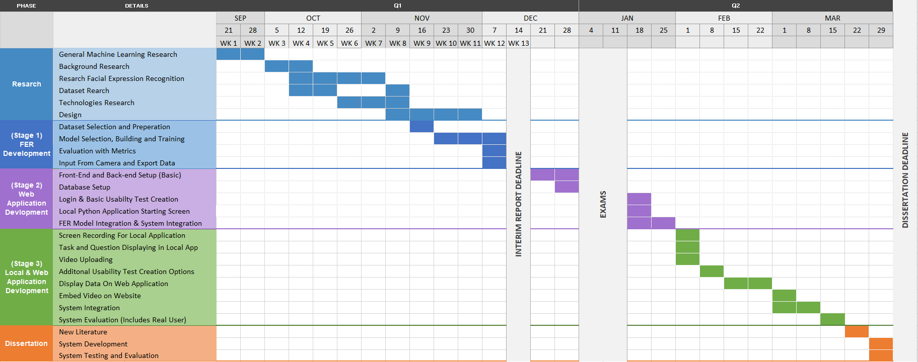

Figure 64 – Sprint Chart Overview (All Stages)

The first two stages are Research and FER Development and illustrated in Figure 65.

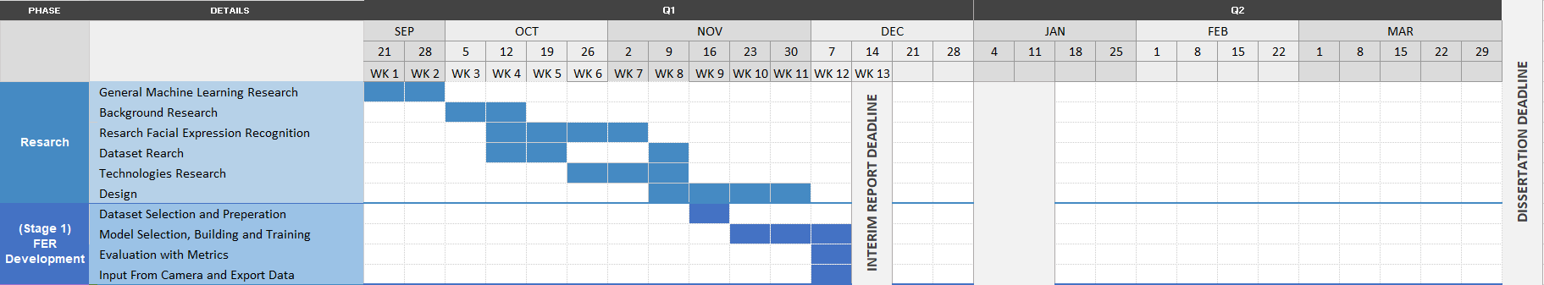

Figure 65 – Sprint Chart First Two Stages (Zoomed in for Readability)

The sprint plan for the last three stages which are Web Application Development, Local Application Development and the Dissertation report are illustrated in Figure 66.

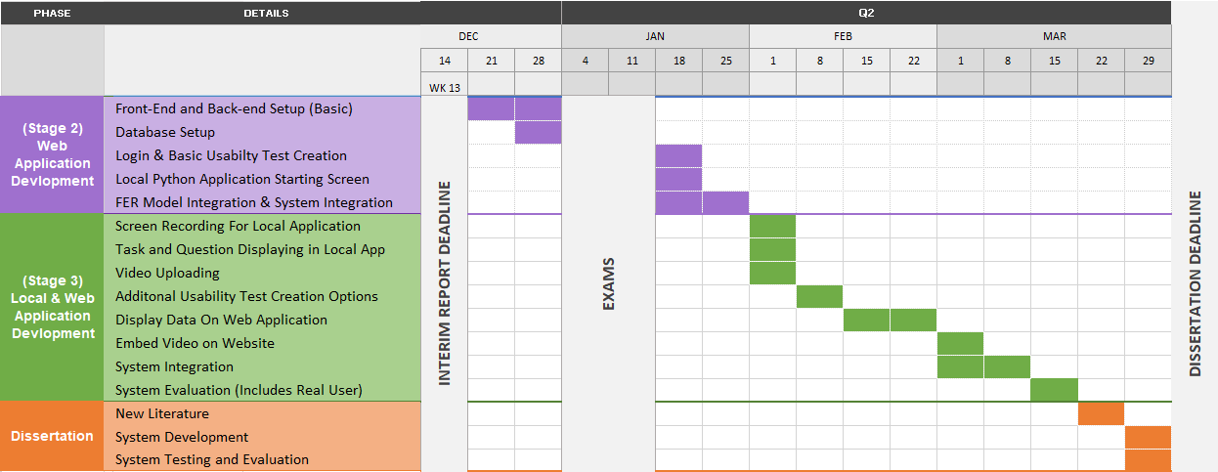

Figure 66 – Sprint Chart Last Three Stages (Zoomed in for Readability)

1.

Faulkner L. Beyond the five-user assumption: Benefits of increased sample sizes in usability testing. Behavior Research Methods, Instruments, & Computers [Internet]. 2003 Aug [cited 2020 Dec 14]; Available from: https://link.springer.com/article/10.3758%252FBF03195514

‌

# Bibliography

1. Return on Investment for Usability [Internet]. Nielsen Norman Group. 2020 [cited 2020 Dec 14]. Available from: <https://www.nngroup.com/articles/return-on-investment-for-usability/>
2. What is Usability Testing? (and What it Isn’t) | Hotjar [Internet]. Hotjar; 2020

[cited 2020 Dec 14]. Available from: <https://www.hotjar.com/usability-testing/>

1. Virzi RA. Refining the Test Phase of Usability Evaluation: How Many Subjects Is Enough? Human Factors: The Journal of the Human Factors and Ergonomics Society [Internet]. 1992 Aug [cited 2020 Dec 14]; Available from: <https://journals.sagepub.com/doi/10.1177/001872089203400407>
2. Faulkner L. Beyond the five-user assumption: Benefits of increased sample sizes in usability testing. Behavior Research Methods, Instruments, & Computers [Internet]. 2003 Aug [cited 2020 Dec 14]; Available from: <https://link.springer.com/article/10.3758%252FBF03195514>
3. Christian Bastien J. Usability testing: some current practices and research questions [Internet]. Available from: <https://arxiv.org/ftp/arxiv/papers/1009/1009.5918.pdf>
4. Landowska, Agnieszka. (2015). Towards Emotion Acquisition in IT Usability Evaluation Context. [cited 2020 Dec 14]; Available from: <https://www.researchgate.net/publication/301454217_Towards_Emotion_Acquisition_in_IT_Usability_Evaluation_Context>
5. Connor Esterwood. Facial Recognition & Journey Mapping for Improved Usability Testing [Internet]. Medium. Medium; 2018 [cited 2020 Dec 14]. Available from: <https://medium.com/@cesterwo/facial-recognition-journey-mapping-for-improved-usability-testing-37269a50b71f>
6. Halder, Rituparna & Sengupta, Sushmit & Pal, Arnab & Ghosh, Sudipta & Kundu, Debashish. (2016). Real Time Facial Emotion Recognition based on Image Processing and Machine Learning. International Journal of Computer Applications.

[cited 2020 Dec 14]; Available from: <https://www.researchgate.net/publication/301335563_Real_Time_Facial_Emotion_Recognition_based_on_Image_Processing_and_Machine_Learning>

1. Gaurav Sharma. Real Time Facial Expression Recognition - Data Driven Investor - Medium [Internet]. Medium. Data Driven Investor; 2018 [cited 2020 Dec 14]. Available from: <https://medium.com/datadriveninvestor/real-time-facial-expression-recognition-f860dacfeb6a>
2. Bastien, J.. (2009). Usability testing: A review of some methodological and technical aspects of the method. International journal of medical informatics. ResearchGate [Internet]. 2020 [cited 2020 Dec 14]; Available from: <https://www.researchgate.net/publication/24256512_Usability_testing_A_review_of_some_methodological_and_technical_aspects_of_the_method>
3. Sarang Narkhede. Understanding Confusion Matrix - Towards Data Science [Internet]. Medium. Towards Data Science; 2018 [cited 2020 Dec 14]. Available from: <https://towardsdatascience.com/understanding-confusion-matrix-a9ad42dcfd62>
4. Koehrsen W. Beyond Accuracy: Precision and Recall - Towards Data Science [Internet]. Medium. Towards Data Science; 2018 [cited 2020 Dec 14]. Available from: <https://towardsdatascience.com/beyond-accuracy-precision-and-recall-3da06bea9f6c>
5. Patel R, Dhakad J, Desai K, Gupta T, Correia S. Hand Gesture Recognition System using Convolutional Neural Networks. 2018 4th International Conference on Computing Communication and Automation (ICCCA) [Internet]. 2018 Dec [cited 2020 Dec 14]; Available from: <https://ieeexplore.ieee.org/document/8777621>
6. Lawrence, Steve & Giles, C & Tsoi, Ah & Back, Andrew. (1997). Face Recognition: A Convolutional Neural Network Approach. ResearchGate [Internet]. 2020 [cited 2020 Dec 14]; Available from: <https://www.researchgate.net/publication/3302251_Face_Recognition_A_Convolutional_Neural_Network_Approach>
7. Cireşan D, Meier U, Schmidhuber J. Multi-column Deep Neural Networks for Image Classification [Internet]. arXiv.org. 2012 [cited 2020 Dec 14]. Available from: <https://arxiv.org/abs/1202.2745>
8. DeepAI. ReLu [Internet]. DeepAI. DeepAI; 2019 [cited 2020 Dec 14]. Available from: <https://deepai.org/machine-learning-glossary-and-terms/relu>
9. Sharma, Neha & Jain, Vibhor & Mishra, Anju. (2018). An Analysis Of Convolutional Neural Networks For Image Classification. ResearchGate [Internet]. 2018 [cited 2020 Dec 14]; Available from: <https://www.researchgate.net/publication/325663368_An_Analysis_Of_Convolutional_Neural_Networks_For_Image_Classification>
10. Stewart M. Simple Introduction to Convolutional Neural Networks [Internet]. Medium. Towards Data Science; 2019 [cited 2020 Dec 14]. Available from: <https://towardsdatascience.com/simple-introduction-to-convolutional-neural-networks-cdf8d3077bac>
11. VGG16 - Convolutional Network for Classification and Detection [Internet]. Neurohive.io. 2018 [cited 2020 Dec 14]. Available from: <https://neurohive.io/en/popular-networks/vgg16/>
12. ImageNet [Internet]. Image-net.org. 2017 [cited 2020 Dec 14]. Available from: <http://image-net.org/index>
13. Sik-Ho Tsang. Review: VGGNet — 1st Runner-Up (Image Classification), Winner (Localization) in ILSVRC 2014 [Internet]. Medium. Coinmonks; 2018 [cited 2020 Dec 14]. Available from: <https://medium.com/coinmonks/paper-review-of-vggnet-1st-runner-up-of-ilsvlc-2014-image-classification-d02355543a11>
14. ImageNet [Internet]. Image-net.org. 2016 [cited 2020 Dec 14]. Available from: <http://image-net.org/about-overview>
15. Kusuma GP, Jonathan J, Lim AP. Emotion Recognition on FER-2013 Face Images Using Fine-Tuned VGG-16. Advances in Science, Technology and Engineering Systems Journal [Internet]. 2020 [cited 2020 Dec 14];5(6):315–22. Available from: <https://www.astesj.com/publications/ASTESJ_050638.pdf>
16. Rohith Gandhi. Support Vector Machine — Introduction to Machine Learning Algorithms [Internet]. Medium. Towards Data Science; 2018 [cited 2020 Dec 14]. Available from: <https://towardsdatascience.com/support-vector-machine-introduction-to-machine-learning-algorithms-934a444fca47>
17. Saptashwa Bhattacharyya. Support Vector Machine: Kernel Trick; Mercer’s Theorem [Internet]. Medium. Towards Data Science; 2018 [cited 2020 Dec 14]. Available from: <https://towardsdatascience.com/understanding-support-vector-machine-part-2-kernel-trick-mercers-theorem-e1e6848c6c4d>
18. Analytics Vidhya. SVM | Support Vector Machine Algorithm in Machine Learning [Internet]. Analytics Vidhya. 2017 [cited 2020 Dec 14]. Available from: <https://www.analyticsvidhya.com/blog/2017/09/understaing-support-vector-machine-example-code/>
19. Aybüke Yalçıner. Bag of Visual Words(BoVW) - Aybüke Yalçıner - Medium [Internet]. Medium. Medium; 2019 [cited 2020 Dec 14]. Available from: <https://medium.com/@aybukeyalcinerr/bag-of-visual-words-bovw-db9500331b2f>
20. Image Classification using Bag of Visual Words Model | MLK - Machine Learning Knowledge [Internet]. MLK - Machine Learning Knowledge. 2020 [cited 2020 Dec 14]. Available from: <https://machinelearningknowledge.ai/image-classification-using-bag-of-visual-words-model/>
21. Divyansh Dwivedi. Face Detection For Beginners - Towards Data Science [Internet]. Medium. Towards Data Science; 2018 [cited 2020 Dec 15]. Available from: <https://towardsdatascience.com/face-detection-for-beginners-e58e8f21aad9>
22. Lyons M, Kamachi M, Gyoba J. The Japanese Female Facial Expression (JAFFE) Dataset. Zenodo [Internet]. 1998 Apr 14 [cited 2020 Dec 14]; Available from: <https://zenodo.org/record/3451524>
23. Rohit Verma. fer2013 [Internet]. Kaggle.com. 2013 [cited 2020 Dec 14]. Available from: <https://www.kaggle.com/deadskull7/fer2013>
24. AffectNet – Mohammad H. Mahoor, PhD [Internet]. Mohammadmahoor.com. 2017 [cited 2020 Dec 14]. Available from: <http://mohammadmahoor.com/affectnet/>
25. Home - FacesDB | VISGRAF [Internet]. Impa.br. 2012 [cited 2020 Dec 14]. Available from: <http://app.visgraf.impa.br/database/faces>
26. Google facial expression comparison dataset [Internet]. Google Research. 2018 [cited 2020 Dec 14]. Available from: <https://research.google/tools/datasets/google-facial-expression/>
27. Emotions in context [Internet]. Uoc.edu. 2019 [cited 2020 Dec 14]. Available from: http://sunai.uoc.edu/emotic/
28. leonshting. leonshting/fec-dataset-loader [Internet]. GitHub. 2020 [cited 2020 Dec 14]. Available from: <https://github.com/leonshting/fec-dataset-loader>
29. alex-miller-0. alex-miller-0/Tor_Crawler [Internet]. GitHub. 2019 [cited 2020 Dec 14]. Available from: <https://github.com/alex-miller-0/Tor_Crawler>
30. Actionable UX insights for better digital experiences [Internet]. Userzoom.com. 2020 [cited 2020 Dec 14]. Available from: <https://www.userzoom.com/>
31. UserTesting: The Human Insight Platform [Internet]. UserTesting. 2020 [cited 2020 Dec 14]. Available from: <https://www.usertesting.com/>
32. Online User Testing Tool | Loop11 [Internet]. Loop11.com. 2020 [cited 2020 Dec 14]. Available from: <https://www.loop11.com/>‌
33. ‌Welcome to Python.org [Internet]. Python.org. Python.org; 2020 [cited 2020 Dec 14]. Available from: <https://www.python.org/>
34. Python Features - javatpoint [Internet]. www.javatpoint.com. 2011 [cited 2020 Dec 14]. Available from: <https://www.javatpoint.com/python-features>
35. The Web framework for perfectionists with deadlines | Django [Internet]. Djangoproject.com. 2020 [cited 2020 Dec 14]. Available from: <https://www.djangoproject.com/>
36. Java.com. 2020 [cited 2020 Dec 14]. Available from: <https://www.java.com/en/>
37. What is Java and why is it important? - Code Institute [Internet]. Code Institute. 2014 [cited 2020 Dec 14]. Available from: <https://codeinstitute.net/blog/what-is-java/>
38. What is JavaScript? [Internet]. MDN Web Docs. 2020 [cited 2020 Dec 14]. Available from: <https://developer.mozilla.org/en-US/docs/Learn/JavaScript/First_steps/What_is_JavaScript>
39. Node.js. Node.js [Internet]. Node.js. 2020 [cited 2020 Dec 14]. Available from: <https://nodejs.org/en/>
40. AngularJS — Superheroic JavaScript MVW Framework [Internet]. Angularjs.org. 2010 [cited 2020 Dec 14]. Available from: <https://angularjs.org/>
41. React – A JavaScript library for building user interfaces [Internet]. Reactjs.org. 2020 [cited 2020 Dec 14]. Available from: <https://reactjs.org/>
42. NumPy [Internet]. Numpy.org. 2019 [cited 2020 Dec 14]. Available from: <https://numpy.org/>
43. pandas - Python Data Analysis Library [Internet]. Pydata.org. 2020 [cited 2020 Dec 14]. Available from: <https://pandas.pydata.org/>
44. Matplotlib: Python plotting — Matplotlib 3.3.3 documentation [Internet]. Matplotlib.org. 2012 [cited 2020 Dec 14]. Available from: <https://matplotlib.org/>
45. scikit-learn: machine learning in Python — scikit-learn 0.23.2 documentation [Internet]. Scikit-learn.org. 2020 [cited 2020 Dec 14]. Available from: <https://scikit-learn.org/stable/>
46. Introduction to TensorFlow [Internet]. TensorFlow. 2020 [cited 2020 Dec 14]. Available from: <https://www.tensorflow.org/learn>
47. Asena Atilla Saunders. Top Five Use Cases of TensorFlow [Internet]. Exastax. Exastax; 2017 [cited 2020 Dec 14]. Available from: <https://www.exastax.com/deep-learning/top-five-use-cases-of-tensorflow/>
48. Keras Team. Keras: The Python deep learning API [Internet]. Keras.io. 2020 [cited 2020 Dec 14]. Available from: <https://keras.io/>
49. Welcome to fastai | fastai [Internet]. Fast.ai. 2020 [cited 2020 Dec 14]. Available from: <https://docs.fast.ai/>
50. Dmytro Mishkin. Fast.ai library: 1st impression - Towards Data Science [Internet]. Medium. Towards Data Science; 2019 [cited 2020 Dec 14]. Available from: <https://towardsdatascience.com/fast-ai-library-1st-impression-958cb52afc>
51. Home - OpenCV [Internet]. OpenCV. 2020 [cited 2020 Dec 14]. Available from: <https://opencv.org/>
52. Multi-cloud storage for your applications of today and tomorrow. SwiftStack Data Platform [Internet]. SwiftStack. 2020 [cited 2020 Dec 14]. Available from: <https://www.swiftstack.com/>
53. StreamingVideoProvider [Internet]. StreamingVideoProvider. 2020 [cited 2020 Dec 14]. Available from: <https://www.streamingvideoprovider.com/>
54. Vimeo [Internet]. Vimeo.com. 2020 [cited 2020 Dec 14]. Available from: <https://vimeo.com/>
55. YouTube Data API  |  Google Developers [Internet]. Google Developers. 2020 [cited 2020 Dec 14]. Available from: https://developers.google.com/youtube/v3
56. Apache Tomcat Project. Apache Tomcat® - Welcome! [Internet]. Apache.org. 2020 [cited 2020 Dec 14]. Available from: <http://tomcat.apache.org/>
57. Five Reasons You Should Use Tomcat (Updated for 2020) [Internet]. Future Hosting. 2014 [cited 2020 Dec 14]. Available from: <https://www.futurehosting.com/blog/five-reasons-you-should-use-tomcat/>
58. Firebase [Internet]. Firebase. 2020 [cited 2020 Dec 14]. Available from: <https://firebase.google.com/>
59. MySQL [Internet]. Mysql.com. 2020 [cited 2020 Dec 15]. Available from: <https://www.mysql.com/>
60. 8 Major Advantages of Using MySQL [Internet]. Datamation.com. 2016 [cited 2020 Dec 15]. Available from: <https://www.datamation.com/storage/8-major-advantages-of-using-mysql.html>
61. Atlassian. What is Scrum? [Internet]. Atlassian. 2018 [cited 2020 Dec 14]. Available from: <https://www.atlassian.com/agile/scrum>
62. Scrum methodology [Internet]. Digital.ai. 2020 [cited 2020 Dec 14]. Available from: <https://digital.ai/glossary/scrum-methodology>
63. Blueprint Software Systems. Benefits and Challenges of Agile Development [Internet]. Blueprintsys.com. 2017 [cited 2020 Dec 14]. Available from: <https://www.blueprintsys.com/agile-development-101/agile-benefits-and-challenges>
64. Scaling Data Science: How We Use CRISP-DM and Agile | AgileThought [Internet]. AgileThought. 2018 [cited 2020 Dec 14]. Available from: <https://agilethought.com/blogs/scaling-data-science-use-crisp-dm-agile/>
65. Crisp DM methodology - Smart Vision Europe [Internet]. Smart Vision Europe. 2020 [cited 2020 Dec 14]. Available from: <https://www.sv-europe.com/crisp-dm-methodology/>
66. Videojs-markers [Internet]. Sampingchuang.com. 2020 [cited 2020 Dec 14]. Available from: <http://sampingchuang.com/videojs-markers>
67. What is Black Box Testing | Techniques & Examples | Imperva [Internet]. Learning Center. 2020 [cited 2020 Dec 14]. Available from: <https://www.imperva.com/learn/application-security/black-box-testing/>
68. White Box Testing: A Complete Guide with Techniques, Examples, & Tools [Internet]. Softwaretestinghelp.com. 2015 [cited 2020 Dec 14]. Available from: <https://www.softwaretestinghelp.com/white-box-testing-techniques-with-example/>
69. Rungta K. What is Grey Box Testing? Techniques, Example [Internet]. Guru99.com. Guru99; 2020 [cited 2020 Dec 14]. Available from:

<https://www.guru99.com/grey-box-testing.html>

1. 10 Usability Heuristics for User Interface Design [Internet]. Nielsen Norman Group. 2020 [cited 2020 Dec 14]. Available from: <https://www.nngroup.com/articles/ten-usability-heuristics/>‌

‌

‌

‌

‌

‌

‌

‌

‌

‌

‌